CAPHY: AN AI-BASED INTELLIGENT SECURITY SYSTEM
WITH TWO-FACTOR MOTION VALIDATION AND
MONITORING PROTOCOLS

A Thesis Presented to the Faculty of the Computer Science
Taguig City University, General Santos Avenue
Central Bicutan, Taguig City

In Partial Fulfillment of the Requirements for the Degree of
Bachelor of Science in Computer Science

By

Khemberly D. Alao
King Leonard V. Kidsolan
Mark Alphy R. Miasis
Aedrean Marl I. Nudalo

May 2026

CHAPTER I

INTRODUCTION

Background of the Study
The rise of Internet of Things (IoT) technology has turned smart home security from a luxury into a standard need. However, most modern security systems rely heavily on centralized cloud architectures. While this setup works well in countries with strong internet infrastructure, a cloud-first approach creates major problems in developing nations like the Philippines. Issues such as high network latency, frequent power outages, data privacy risks, and the high cost of proprietary hardware make these systems difficult to use for the average Filipino household. Additionally, traditional security cameras often cause “alert fatigue,” constantly sending notifications for harmless background movements, which eventually makes users ignore actual threats.

Rationale
The name CAPHY itself began informally during early planning, as a shorthand blend of “Capture” — the system’s core function of capturing motion and images — and “Alphy,” a nod to team member Mark Alphy R. Miasis. What started as a casual working title stuck with the group and was carried forward as the project’s formal name, eventually standing for the system now described throughout this study: an AI-Based Intelligent Security System with Two-Factor Motion Validation and Monitoring Protocols.
This study argues that by repurposing such devices into a Repurposed Hardware Architecture and performing the primary artificial-intelligence processing locally, homes can achieve dependable security monitoring while keeping the overall cost low.
CAPHY performs its artificial-intelligence processing — motion detection and object verification — locally on the host laptop, so the system continues to detect and respond to threats even when the internet is down. Connectivity is then used adaptively rather than constantly: when the internet is available, verified alerts and captured media are delivered as push notifications through the dedicated CAPHY App and synced to cloud storage; when the connection is offline or the signal is weak, the same data is stored locally and compressed to conserve space until connectivity returns. Simply put, the laptop does the guarding and the internet does the messaging: detection, recording, the siren, and core voice commands run on the laptop with or without internet, while phone alerts and cloud backup resume automatically once a connection is available. In this way a household gains resilient security without paying recurring subscription fees or depending on a constant, high-speed internet connection.

Project Context
This project introduces CAPHY: An AI-Based Intelligent Security System, built to operate within the connectivity and power constraints common to Philippine households. CAPHY performs its core artificial-intelligence tasks — video motion analysis and object verification — locally on a repurposed host laptop, allowing threat detection to continue during internet or power interruptions. The system is neither fully cloud-dependent nor fully offline; instead, it adapts to the connectivity that is available. When the internet is present, verified alerts and captured media are transmitted to the homeowner through the dedicated CAPHY App and synced to cloud storage. When the network is offline or the signal is weak, the same data is retained in compressed form in local storage until a connection is restored. Live camera viewing, meanwhile, is served only over the home’s local Wi-Fi network, keeping continuous video off the public internet. In effect, the host laptop acts as an autonomous local server that uses internet bandwidth opportunistically rather than continuously.

Purpose and Description

The main goal of this study is to build a smart, resilient, and affordable home-security system using a Repurposed Hardware Architecture. CAPHY uses a Two-Factor Motion Validation protocol that combines OpenCV to detect initial movement (Factor 1) and a YOLO model to confirm whether that movement is an actual person or object (Factor 2). By requiring both factors before raising an alarm, the system filters out false alarms, conserves processing power, and reduces alert fatigue — the tendency for users to stop paying attention to notifications when too many of them turn out to be false.

CAPHY features a Proximity-Based Alert system delivered through the CAPHY App, the system’s own dedicated mobile application, which receives push notifications through Firebase Cloud Messaging. The system classifies detections through a Three-Tier response: Tier 1 sends a snapshot and a notification; Tier 2 adds a short video clip on top of the snapshot and notification; and Tier 3 adds the audible siren on top of the snapshot, video, and notification. When the system is placed in Armed mode, every tier escalates directly to the full Tier 3 response — siren, recording, and high-priority alert — so no detection is under-reported while the household is actively secured. To keep the tier stable in normal monitoring, CAPHY smooths the estimated distance over successive frames and applies hysteresis at each tier boundary, so a person standing near a threshold does not cause the tier — and the siren — to flicker.
The system also includes a Tagalog-capable voice engine with a back-and-forth (multi-turn) confirmation feature, allowing users to control the system by voice when the required device configuration is available. This voice control is designed to support a limited set of predefined security commands locally, while broader functionality may depend on internet availability and compatible system configuration. It is therefore presented as a supported but bounded feature rather than a fully autonomous PC-side voice system.

To keep the system usable at night, CAPHY applies a software-based night-vision mode that brightens and enhances the camera feed in low light, allowing detection to continue in dim conditions without additional infrared hardware. For safe operation, the system starts in a disarmed state and applies a brief arming grace period, so that arming the system — or launching it while the user is still in front of the camera — does not immediately trigger the siren. A short camera warm-up period on startup likewise prevents false alerts from firing before the feed has stabilized.

Objectives of the Study
This study aims to improve the accessibility and reliability of smart home security by developing CAPHY, a localized AI-based security system that combines two-factor motion validation with adaptive monitoring protocols suited to variable power and internet conditions.

Specific Objectives
- To implement a Repurposed Hardware Architecture in which an older or unused laptop serves as the local security server — performing AI processing on-device and using its built-in battery as backup power — so the system keeps running during power and internet interruptions, syncing to cloud storage when connectivity is available and storing data locally (compressed) when it is not.
- To develop a Two-Factor Motion Validation protocol using OpenCV and YOLO to reduce false threats and minimize alert fatigue.
- To integrate a Monitoring Protocol through the CAPHY App that adjusts data transmission, such as images versus video, based on the 3-Tier Threat Level logic and the current network conditions.
- To construct a Tagalog-capable Voice Engine with a multi-turn confirmation system that supports a defined set of security commands locally, helping prevent accidental triggers from background noise.
- To test and evaluate CAPHY: An AI-Based Intelligent Security System with Two-Factor Motion Validation and Monitoring Protocols using the ISO/IEC 25010 software-quality standard in terms of the following: Functional Suitability, Performance Efficiency, Compatibility, Usability, Reliability, Security, Maintainability, and Portability.

Conceptual Framework

CAPHY: AN AI-BASED INTELLIGENT SECURITY SYSTEM WITH TWO-FACTOR MOTION VALIDATION AND MONITORING PROTOCOLS

To enhance the accessibility and reliability of smart home security through a localized, AI-based system that combines two-factor motion validation with adaptive monitoring protocols suited to variable power and internet conditions
Knowledge Requirements

Hardware Requirements:
- Standard host laptop or desktop (repurposed as the server)
- Built-in laptop camera, USB webcam, or phone camera (via IP-camera streaming); the system supports up to two cameras at a resolution of 640 × 480

Software Requirements:
- Python with Flask (local server, REST API, and MJPEG live stream)
- YOLOv8 models; OpenCV (with CLAHE low-light enhancement)
- Vosk offline speech recognition
- CAPHY App (Flutter mobile application) with Firebase Cloud Messaging
- SQLite local database; Windows OS

Live System Data:
- Real-time video feeds
- Tagalog/English voice commands
- Laptop battery status
- Current network status (online, offline, or low-signal)

Methodology

Iterative System Development:
- Planning
- Coding
- Testing

AI Integration:
- OpenCV pixel-shift detection with CLAHE night-vision enhancement
- YOLO object classification and proximity-tier estimation, stabilized with distance smoothing and hysteresis
- Local (offline-capable) voice processing

Adaptive Storage & Alerting:
- Firebase push alerts and cloud sync when online; compressed local storage when offline or on a weak signal

System Evaluation using ISO/IEC 25010:
- Functional Suitability, Performance Efficiency, Compatibility, Usability, Reliability, and Security, Maintainability, and Portability.
PROCESS
OUTPUT
INPUT

FEEDBACK

Figure 1. Conceptual Paradigm
The conceptual framework of the study, as shown in Figure 1, utilizes the Input–Process–Output (IPO) model to illustrate the development and operational flow of the CAPHY system. A feedback loop is integrated to ensure continuous system refinement based on the results of the software evaluation.
The Input consists of the essential knowledge, hardware, software, and live data required to initiate the project. The Hardware Requirements include a standard laptop or desktop acting as the repurposed server and two independently controlled cameras, which may be USB webcams, Bluetooth-connected cameras, or smartphone cameras streamed through a companion app. Each camera supports a resolution of 960 × 480 and can be opened or closed independently. The Software Requirements include Python with Flask for the local server, YOLOv8 and OpenCV for AI and computer vision, Vosk for offline speech recognition, SQLite for local event logging, and the Flutter-based CAPHY App with Firebase Cloud Messaging for remote alerts. The system also uses Live System Data, such as real-time video feeds, Tagalog/English voice commands, battery status, and network status, to determine whether data should be synchronized to the cloud or stored locally.
The Process encompasses the development methodology and the core technical operations. The Iterative System Development stage involves a cycle of planning, coding, and testing. This is followed by the AI Integration, which represents the primary technical innovation of the study: using OpenCV for pixel-shift detection and YOLO for object classification to form the Two-Factor Motion Validation protocol, supported by CLAHE-based low-light enhancement and proximity-tier estimation with distance smoothing and hysteresis. This stage also includes local, offline-capable voice processing for command execution. In parallel, an Adaptive Storage and Alerting layer routes captured media and alerts to cloud storage and Firebase push notifications when the connection is available and to compressed local storage when it is not, with a background retry process ensuring queued items are correctly marked as synced once uploaded. Finally, the system undergoes a rigorous evaluation using the ISO/IEC 25010 standard, specifically testing for Functional Suitability, Performance Efficiency, Usability, Reliability, and Security.
The Output of the study is the completed CAPHY system, a resilient, privacy-conscious solution that keeps artificial-intelligence processing on the local device and delivers intelligent remote alerts through its own dedicated app. This is supported by a Feedback loop, where evaluation data from IT experts and end-users is used to refine the system’s logic and inputs, ensuring the final architecture meets all professional standards and user needs.

Scope
This study focuses on the development of CAPHY, a localized AI-based security system that uses two-factor motion validation and adaptive remote-monitoring protocols. While the system’s Repurposed Hardware Architecture is ultimately designed to serve as an affordable, resilient security solution for average Filipino households, the actual deployment, testing, and evaluation of the prototype will be conducted in controlled environments — specifically, a university laboratory setting, complemented by testing in a house setting to simulate residential conditions, including nighttime operation and scenarios with lights switched on and off, to validate its technical performance.
The project implements features for accurate threat detection, offline voice control, and adaptive alert management. It uses a Repurposed Hardware Architecture, allowing the host laptop’s built-in battery to support operation during short power interruptions. A Tagalog-capable Voice Engine enables real-time offline control using core voice commands, while the CAPHY App with Firebase Cloud Messaging delivers verified security alerts to authorized users under varying network conditions. Evidence is synchronized to cloud storage when online and stored locally in compressed form when offline or on a weak connection. The system also includes CLAHE-based night vision for improved low-light visibility and a Tier-3 audible siren that remains active until the alert is acknowledged through the app, dashboard, or voice command. To reduce false alarms, CAPHY starts disarmed, applies a short arming grace period, suppresses the siren during this period, and uses a brief camera warm-up before detection begins. For the initial laboratory phase, camera input will depend on equipment availability: the system supports a wired (USB) webcam, a Bluetooth-connected camera, or a smartphone camera streamed over the local network via a companion app, whichever is accessible at the time of testing.

Limitations
The system is limited to localized security-management features within the designated residential testing sites; it excludes the monitoring of other locations or facilities beyond these controlled environments. The system supports two simultaneous camera feeds, each independently controlled and opened or closed on its own. Live remote viewing operates over the local Wi-Fi network only and is subject to minor streaming delay rather than being perfectly instantaneous. Software-based night vision improves visibility in low light but does not provide true vision in total darkness without added infrared hardware. The 3-Tier Threat Level uses distance thresholds of greater than 4.5 meters for Tier 1, between 2.5 and 4.5 meters for Tier 2, and less than 2.5 meters for Tier 3; because the distance is estimated from the height of the detection bounding box rather than a dedicated depth sensor, these thresholds remain subject to calibration during testing. Lastly, the voice engine assistance and system control are strictly limited to pre-defined security commands and do not support general conversational interactions.

Significance of the Study
This study is focused on CAPHY, a localized AI-based security system utilizing two-factor motion validation and adaptive remote monitoring, prototyped at Taguig City University. The significance of this study is to ensure that residential security is accessible, resilient, and privacy-conscious, allowing homeowners and researchers to deliver the best out of modern technology despite infrastructure limitations. With this, there would be a significant improvement in domestic safety performance; when households are secured reliably, it creates a positive impact on the community and the nation at large by reducing property-related crimes and enhancing public peace of mind. This research holds significance for both educational institutions and policymakers, as it facilitates the development of appropriate policies regarding hardware sustainability and the formulation of effective solutions to address challenges arising from the “digital divide” and inconsistent internet infrastructure.
For Filipino Homeowners, this research offers an affordable, low-cost-to-run alternative to commercial systems. Because AI processing runs locally and the system falls back to battery power and local storage, it functions reliably despite local power interruptions (brownouts) or slow internet speeds, providing a user-friendly platform for protecting their families and properties.
For the Cybersecurity and Data Privacy Sector, this study demonstrates how a hybrid local–cloud design can strengthen residential data privacy. Because video is analyzed on the local device, live viewing stays on the local network, and alerts are routed through the system’s own dedicated CAPHY App rather than a third-party messaging platform, exposure of private footage is minimized. When cloud storage is used, it is the system’s own configured storage under the owner’s control, consistent with responsible handling of personal data under the Data Privacy Act (RA 10173).
For Future Researchers, this study provides a foundational architecture for further work in resilient smart-home security, including offline-capable Tagalog voice control, self-hosted alert delivery through a dedicated app, and the sustainable repurposing of outdated hardware.
For the Academic Institution, this project will serve as a foundational testing ground. By allowing the researchers to simulate a residential deployment within a university laboratory setting, it streamlines the practical application of AI and computer vision in a real-world setting, creating opportunities for technical learning and future collaboration among student research initiatives.

Operational and Technical Definition of Terms
Alert Fatigue – Technically, the psychological phenomenon in which a user becomes desensitized to frequent security notifications. Operationally, CAPHY reduces it by using Two-Factor Motion Validation so that only verified threats trigger a notification.
Armed Mode – Operationally, a heightened-security state in which any confirmed detection, regardless of tier, is escalated directly to a full Tier 3 response — siren, video recording, and high-priority alert — removing the graduated response used during normal monitoring.
Arming Grace Period – Operationally, a short interval (eight seconds by default) after the system is armed during which alerts and the siren are suppressed, so arming the system — or launching it while the user is still in view of the camera — does not immediately trigger an alarm. CAPHY also starts in a disarmed state for the same reason.
CAPHY – The name of the proposed system: an AI-Based Intelligent Security System with two-factor motion validation and monitoring protocols. Operationally, it is the central software hub that manages motion detection, voice commands, storage, and remote alerts.
CAPHY App – Operationally, the system’s own custom-built mobile companion application, developed with Flutter, which receives and displays remote alerts, threat snapshots, and video clips from the host laptop through Firebase Cloud Messaging, without relying on a third-party messaging platform.
CLAHE (Contrast Limited Adaptive Histogram Equalization) – Technically, an image-processing technique that improves local contrast in dark images. Operationally, it is the software method behind CAPHY’s night-vision mode, brightening the camera feed so detection remains usable in low light.
Camera Warm-Up Period – Operationally, a short interval after a camera is opened or the system is launched during which detection results are held back, preventing false alerts caused by the feed stabilizing (auto-exposure and auto-focus settling).
Edge (Local) AI Processing – Technically, the methodology of running AI algorithms on the local hardware device rather than on a remote cloud server. Operationally, CAPHY performs motion detection and object verification on the host laptop, so detection works even without internet; this is combined with cloud storage when a connection is available.
Firebase Cloud Messaging (FCM) – Technically, a cross-platform push-notification service. Operationally, it is the delivery channel that carries CAPHY’s verified alerts from the host laptop to the CAPHY App on the owner’s phone whenever an internet connection is available.
Hybrid Local–Cloud Architecture – Operationally, CAPHY’s overall design in which AI processing is performed locally while storage and alert delivery adapt to connectivity — syncing to the cloud when the internet is available and saving to compressed local storage when offline or on a weak signal. The cloud layer is implemented using Firebase, specifically Firestore for event data, Firebase Storage for media, Firebase Authentication for user accounts, and Firebase Cloud Messaging for alerts.
MJPEG Live Stream – Technically, a video stream composed of sequential JPEG frames served over HTTP. Operationally, it is how CAPHY provides live camera viewing to devices on the same local Wi-Fi network, keeping continuous video off the public internet.
Multi-Turn Dialogue – Operationally, the voice engine’s confirmation protocol, which requires a back-and-forth interaction between the system and the user to prevent accidental triggers from background noise.
Night Vision (Low-Light Enhancement) – Operationally, a software-based mode, implemented with CLAHE, that brightens and enhances the camera feed so detection remains usable in dim conditions; it improves low-light visibility but does not provide vision in total darkness without added infrared hardware.
OpenCV (Open-Source Computer Vision Library) – Technically, an open-source library used for real-time computer vision. Operationally, it is the “First Factor” of motion detection, used to identify pixel-shifts before activating heavier AI models.
Repurposed Hardware Architecture – Operationally, the system design of using older or depreciated laptops to serve as the local security server, utilizing their built-in batteries as an Uninterruptible Power Supply (UPS) during power outages.
Tagalog-Capable Voice Engine – Operationally, the voice-control component that recognizes a defined set of predefined security commands in Tagalog/English. It works offline for these core commands and can operate with broader capability when an internet connection is available; it is not a fully offline or general conversational engine.
3-Tier Threat Level – Operationally, the proximity-based logic that classifies a detected person by distance — estimated from the height of the detection bounding box — and sets the system’s response. A person farther than 4.5 meters is Tier 1 (Far), which triggers a snapshot and a notification; between 2.5 and 4.5 meters is Tier 2 (Medium), which adds a short video clip; and closer than 2.5 meters is Tier 3 (Close), which adds the audible siren on top of the snapshot, video, and notification. Under Armed Mode, every tier escalates directly to the full Tier 3 response. To keep the classification steady during normal monitoring, the estimated distance is smoothed across frames and a hysteresis margin is applied at each boundary. (Distance thresholds are calibratable during testing.)
Two-Factor Motion Validation – Operationally, a dual-layer detection process in which OpenCV first detects movement (Factor 1) and the YOLO model then confirms whether the movement is a specific object or person (Factor 2) before an alert is sent.
YOLO (You Only Look Once) – Technically, a state-of-the-art, real-time object-detection system. Operationally, it is the “Second Factor,” used to classify detected motion into specific categories such as “person.”

CHAPTER II

REVIEW OF RELATED LITERATURE AND STUDIES
This chapter presents a review of related literature and studies that provide the conceptual and technical foundation for the CAPHY system. The review is organized thematically around the core problems that CAPHY addresses: localized processing and data privacy, hardware sustainability and lightweight motion validation, adaptive alerting under unreliable networks, offline-capable voice interaction, user-centered mitigation of alert fatigue, and the economic viability of repurposed consumer hardware. Together, these themes situate CAPHY within existing research and clarify the gap it is designed to fill for the average Filipino household.

Localized Processing and Data Privacy
A growing body of work supports the shift of artificial-intelligence workloads from centralized cloud servers toward the network edge. IBM (2024) explains that edge AI processes data on or near the device where it is generated, which reduces latency, lowers the volume of data that must be transmitted, and keeps sensitive information on the local device, thereby making it easier to comply with privacy regulations. These are precisely the properties CAPHY relies on: motion analysis and object verification are performed on the host laptop so that detection continues even when connectivity is poor, while only verified alerts are transmitted outward.
The privacy motivation for local processing is well documented in the smart-home security literature. Hall et al. (2020) surveyed the security challenges and privacy concerns of smart homes and found that the continuous transmission of household data to third-party servers substantially widens the attack surface. Industry reporting reinforces this: consumer smart-camera products have been found uploading footage to the cloud without clear user consent, and large-scale breaches of smart-home platforms have exposed millions of records containing credentials and precise location data (Hall et al., 2020). This body of evidence supports CAPHY’s design choice to analyze video locally and route alerts through its own dedicated application rather than a third-party messaging service.

In the Philippine legal context, Republic Act No. 10173, the Data Privacy Act of 2012, establishes the duty of personal-information controllers to protect personal data and created the National Privacy Commission to enforce it (Official Gazette, 2012). Because residential surveillance footage constitutes personal information, keeping processing on the local device and confining stored media to the owner’s own configured storage directly supports compliance and reduces the risk of unauthorized third-party access. This grounds CAPHY’s hybrid design, in which the cloud is used for the owner’s own synchronization rather than for exposing raw footage to external platforms.
The technical feasibility of localized visual detection is well established. Redmon et al. (2016) introduced the You Only Look Once (YOLO) architecture, which frames detection as a single-stage regression problem and processes images in real time, making it markedly faster than earlier multi-stage detectors. Building on this lineage, Ultralytics (2023) documents that the YOLOv8 family, and the lightweight YOLOv8-nano variant in particular, is optimized to run efficiently across hardware ranging from CPUs to GPUs. Together these works justify CAPHY’s use of YOLO as a real-time local validator capable of running on ordinary laptop hardware.

Hardware Sustainability and Software-Based Motion Validation
Running deep-learning vision models continuously on consumer hardware raises sustainability concerns. Benoit-Cattin, Velasco-Montero, and Fernández-Berni (2020) studied long-term visual inference on a CPU-based edge device and demonstrated that sustained convolutional-network workloads quickly drive processor temperature to the point of thermal throttling, degrading frame rates within seconds to minutes unless active thermal management is applied. This finding is a strong argument against naïvely running a heavy detector around the clock and motivates an architecture that invokes the expensive model only when necessary.
Lightweight motion techniques provide exactly this kind of gating. Singla (2014) showed that frame differencing, which compares consecutive frames to flag pixel-level change, is computationally inexpensive relative to deep-learning approaches and effective for detecting movement. This provides the technical basis for CAPHY’s use of OpenCV as a low-cost “software tripwire” that continuously watches for change while consuming minimal processing power.
Combining these two insights yields CAPHY’s Two-Factor Motion Validation. OpenCV frame differencing serves as the always-on first factor, and the heavier YOLO model is activated only after motion is detected, so peak processing and heat are incurred only when a genuine physical change is present. This staged approach aligns with the spirit of Republic Act No. 11285, the Energy Efficiency and Conservation Act, which institutionalizes the judicious use of energy as national policy (Official Gazette, 2019), by minimizing unnecessary computation and power draw.
Resilience against power interruptions is equally important in the Philippine setting. The Philippine Institute for Development Studies (2024) reported that recurring outages across the Luzon grid expose the need for greater reliability and modernization, reflecting the brownouts that Filipino households routinely experience. This reality underscores the value of CAPHY’s Repurposed Hardware Architecture, which leverages a laptop’s built-in battery as backup power so that monitoring can continue through short outages.

Adaptive Alerting under Unreliable Networks
Alert delivery in the Philippines must contend with inconsistent connectivity. The Philippine Institute for Development Studies (2024) and the World Bank (2025) both document persistent gaps in fixed-broadband penetration and affordability, with a large share of households lacking reliable internet access. Under such conditions, depending on high-definition video streaming to convey an emergency is fragile, which justifies an adaptive strategy that prioritizes a lightweight payload first.
The choice of delivery channel also matters. Industry analyses of push notifications versus SMS note that application-based push provides fast, low-latency delivery when a device is online, and is best paired with a fallback for degraded conditions (Pushwoosh, 2024). CAPHY implements this concept through its own dedicated CAPHY App, which receives push notifications through Firebase Cloud Messaging, achieving the low-latency delivery the literature calls for while keeping alert data within the researchers’ own infrastructure rather than routing it through a third-party consumer messaging provider.
Research on constrained-network media transmission supports CAPHY’s escalation logic. Hojjat, Haberer, and Landsiedel (2024) presented MCUCoder, an adaptive-bitrate compression approach for IoT devices that produces a progressive bitstream sorted by importance, allowing the amount of data transmitted to scale with available bandwidth. This mirrors CAPHY’s Adaptive Remote Monitoring, in which a compressed image alert is sent first and heavier video is transmitted only when the network and threat level permit. It also aligns with CAPHY’s hybrid storage behavior, syncing evidence to the cloud when online and retaining it in compressed local storage when offline or on a weak signal.

Offline-Capable Voice Interaction
Commercial voice assistants illustrate the privacy cost of cloud-based speech processing. After detecting a wake word, devices such as Amazon Alexa and Google Assistant transmit captured audio to remote servers for processing, and reports of frequent false activations and human review of recordings have raised significant privacy concerns, culminating in regulatory action over mishandled voice data (Federal Trade Commission, 2023). These concerns make a strong case for a locally hosted voice engine that does not depend on continuous cloud transmission.
Offline recognition is technically viable on modest hardware. Alpha Cephei (2023) documents that the Vosk toolkit performs speech recognition without an internet connection using compact acoustic models of roughly 50 MB, supports more than twenty languages including Filipino, and scales down to low-power devices. This directly supports CAPHY’s Tagalog-capable Voice Engine, which is designed to remain usable offline for a defined set of core security commands while offering broader capability when connectivity is available. Localized language support strengthens this approach. de Goma et al. (2024) fine-tuned a Wav2Vec2.0 model for a Tagalog accent and achieved usable word-level accuracy with only about one hour of labeled data, demonstrating that locally trained models can recognize Filipino speech effectively despite limited resources. This evidence supports the feasibility of recognizing a small, fixed vocabulary of Tagalog and Taglish commands on the host laptop.
Finally, requiring confirmation mitigates accidental activation. Because voice systems are known to trigger on unintended speech (Federal Trade Commission, 2023), CAPHY adds a multi-turn confirmation step in which the system requests a back-and-forth acknowledgment before executing sensitive actions, reducing the risk of false shutdowns or accidental alarm deactivation caused by background noise.

User-Centered Design and Alert-Fatigue Mitigation
Excessive notifications undermine security. Analyses of alert fatigue report that when users are flooded with alerts, many of which are false positives, they become desensitized and begin to ignore even legitimate warnings (Proofpoint, 2024; IBM, 2024). Surveys cited in this literature indicate that a majority of alerts are false or redundant and that most organizations regard alert fatigue as a top operational challenge. For a home system, the same dynamic means that constant, non-critical pings would train users to disregard genuine threats, which is exactly the failure mode CAPHY’s Two-Factor Motion Validation is intended to prevent.
Distinguishing a genuine approach from harmless distant motion requires a sense of proximity. Liang, Ma, and Zhang (2022) demonstrated self-supervised object-distance estimation from a single monocular camera, using detection outputs to infer distance without dedicated depth hardware. This confirms the feasibility of CAPHY’s software-based proximity estimation, in which the height of a detected person’s bounding box serves as a distance proxy, eliminating the need for expensive sensors such as LiDAR.
Proximity information enables CAPHY’s 3-Tier Threat Level by classifying detected events based on distance. Events beyond 4.5 meters are logged, those between 2.5- and 4.5-meters trigger alerts with media, and events within 2.5 meters escalate to a critical alert with a siren. Distance smoothing and hysteresis help stabilize the classification and prevent repeated siren activation when a person remains near a boundary. This tiered approach reduces unnecessary alerts and converts raw detections into meaningful, context-aware responses.

Economic Viability of Repurposed Consumer Electronics
Affordability is a central barrier to home security in the Philippines. Studies of the country’s digital divide document low broadband penetration and some of the least affordable mobile data in the region, disproportionately affecting lower-income households (Philippine Institute for Development Studies, 2024; World Bank, 2025). In this context, commercial subscription-based security systems remain out of reach for many families, motivating low-cost alternatives.
The frugal-innovation paradigm offers a framework for such alternatives. The World Economic Forum (2023) describes frugal technology as delivering more value with fewer resources, often by replacing dedicated hardware with software and by repurposing existing tools, and cites deployments in the Philippines and other developing economies. CAPHY embodies this principle by shifting the intelligence of a security system into software running on hardware that households already own.
Reusing existing devices also carries a sustainability benefit. The Environmental Management Bureau (2025) notes that electronic waste is a growing problem in the Philippines, with discarded devices posing environmental and health risks when improperly handled. Repurposing older laptops and existing webcams as security infrastructure extends the useful life of this hardware and reduces e-waste while providing capable local computing at a near-zero entry cost.
Consumer laptops are particularly well suited to this role. Unlike bare microcontrollers, a laptop integrates a built-in battery that functions as an uninterruptible power supply during brownouts and provides sufficient processing power to run staged AI workloads, provided that heavy inference is gated to avoid the thermal throttling documented by Benoit-Cattin et al. (2020). This combination of resilience, capability, and zero acquisition cost underpins CAPHY’s Repurposed Hardware Architecture.

Synthesis of the Related Literature and Studies
The reviewed literature highlights the need to shift from centralized, cloud-dependent surveillance toward intelligent systems that process data locally and remain reliable under Philippine conditions. Previous studies support key components of the
proposed system, including YOLO for fast object detection, frame-difference motion detection, edge processing for privacy, offline speech recognition, proximity estimation, adaptive data transmission, and hardware reuse. The literature also emphasizes concerns such as CPU limitations, alert fatigue, data privacy under RA 10173, and unstable network connectivity, providing a strong foundation for CAPHY’s design.
What remains missing is an integration of these elements into a single, sustainable architecture tailored to Filipino households, one that simultaneously answers network unreliability, power instability, data-privacy law, economic constraints, and alert fatigue. CAPHY addresses this gap. Through a Repurposed Hardware Architecture it turns an idle laptop into a battery-backed local server; through Two-Factor Motion Validation it protects that hardware from exhaustion while filtering out false alarms; through a tiered, Proximity-Based Alert system delivered by its own Flutter-based CAPHY App via Firebase Cloud Messaging it ensures a fast image alert reaches the user before heavier video, syncing to the cloud when online and to compressed local storage when offline, without exposing footage to third-party platforms; and through an offline-capable Tagalog voice engine with multi-turn confirmation it provides natural, resilient control. In combining these into one hybrid, context-aware, and cost-effective solution, CAPHY advances beyond the individual contributions of the reviewed literature.

CHAPTER III

RESEARCH METHODOLOGY
This chapter presents the procedures, methodologies, and technical requirements used to develop and evaluate the CAPHY smart home security system, including the research design, respondents, data-gathering instruments, statistical treatments, and algorithms necessary to achieve the study’s objectives.

Research Methodology
This study will use the Applied Research Method together with the Agile Prototyping Software Development Life Cycle, specifically the Scrum methodology. Applied research is appropriate because the study aims to address real-world problems in smart home security, particularly alert fatigue, network dependency, and system reliability within the Philippine context. The Agile approach allows CAPHY to be developed and improved through iterative cycles, where features such as motion detection, tier thresholds, low-light enhancement, remote monitoring, and the CAPHY App are tested and refined. After development, the completed prototype will undergo final system evaluation.

Population, Sample Size, and Sampling Technique
The population of the study comprises residential homeowners and computer laboratory personnel with relevant technical background. The researchers will select a sample size of fifty participants composed of 45 homeowners and 5 computer laboratory personnel. The computer laboratory personnel will evaluate the system’s technical aspects, while the homeowners will assess the usability of the Tagalog voice commands and CAPHY App alerts, ensuring both technical and practical evaluation of the system. The researchers will employ purposive sampling to select homeowners and computer laboratory personnel who meet the study’s evaluation criteria. To reach the target sample size, the researchers will also use an iterative referral process, asking initial respondents to recommend other qualified individuals with relevant knowledge and experience.

Table 1:
Distribution of Respondents
Respondents | Sample (n) | Percentage (%)
Residential Homeowners | 45 | 90%
Computer Laboratory Personnel | 5 | 10%
Total | 50 | 100%

Table 1 presents the target percentage distribution of the respondents. It shows that 90% of the respondents will be residential homeowners, making up the largest group in the study, while computer laboratory personnel will comprise the remaining 10%. This indicates that the majority of the participants will be homeowners, whose feedback centers on everyday usability, complemented by a smaller group of computer laboratory personnel who provide a more technical evaluation of the system.

Research Instrument
The research study, “CAPHY: An AI-Based Intelligent Security System with Two-Factor Motion Validation and Monitoring Protocols,” will utilize a structured survey questionnaire to gather feedback from participants. The questionnaire is designed using the ISO/IEC 25010 software-quality model, focusing on key metrics such as Functional Suitability, Performance Efficiency, Usability, Reliability, and Security. It aims to evaluate participants’ experiences while interacting with the system and to collect quantitative data on its overall effectiveness.

Data Gathering Procedure
Purposive sampling is a non-random sampling method in which researchers intentionally select participants based on criteria relevant to the research objectives. It focuses on individuals who possess the specific characteristics, experience, or knowledge needed to answer the research questions. This technique is suitable for this study since respondents are expected to directly interact with and evaluate the CAPHY system.
To gather data systematically, the CAPHY system will first be deployed in the testing environments — a university laboratory setting and a house setting — and
participants will be briefed on how to use the cameras, read CAPHY App alerts, and operate the Tagalog voice commands, which run offline for the system’s core command set. The respondents will then simulate real-world usage by triggering motion events at varying distances to test the Two-Factor Motion Validation and the escalation of the 3-Tier Threat Level (beyond 4.5 meters, between 2.5 and 4.5 meters, and within 2.5 meters), including how Armed mode escalates every tier to the full siren response; repeating these tests in daytime and nighttime conditions, with lights switched on and off, to observe the CLAHE-based low-light (night-vision) detection; and using the CAPHY App, the local dashboard, or voice commands to arm or disarm the system and to acknowledge a Tier-3 siren. After the simulation, a structured questionnaire based on the ISO/IEC 25010 standard will be distributed through face-to-face or online channels. Finally, all responses will be collected, tallied, organized, and prepared for statistical analysis to evaluate the system’s overall performance.

Statistical Treatment of Data
To ensure a rigorous evaluation of the CAPHY system, the gathered data will be subjected to descriptive statistical analyses. These tools will enable the researchers to identify patterns regarding system responsiveness, threat-detection accuracy, and overall user interaction.
- Frequency and Percentage Distribution. These descriptive statistics will be used to classify the respondents according to their demographic profiles. Percentages will be calculated by dividing the frequency of a specific demographic or response by the total number of respondents, scaled by one hundred, establishing the demographic validity of the testing group.
P = (f / N) × 100
Where: P = Percentage; f = Frequency; N = Total number of respondents.

- Weighted Mean. The weighted mean will serve as the primary metric to determine the system’s overall acceptability. It provides a method of estimating the expected mean of the Likert-scale responses across the ISO/IEC 25010 criteria, including Functional Suitability and Performance Efficiency. It multiplies the frequency of responses by their corresponding unit weights.
WM = Σ(f × w) / N
Where: Σ = Summation; f = Frequency of responses; w = Numerical weight assigned to each response; N = Total number of respondents.

- Standard Deviation. To measure the dispersion of the evaluation scores around the mean, the standard deviation will be calculated. A low standard deviation indicates that the respondents’ evaluations are closely clustered around the mean, confirming a strong consensus among participants regarding the system’s reliability and usability.
SD = √( Σ(x − x̄)² / N )
Where: x = Individual score/response; x̄ = Mean of the dataset; N = Total number of respondents.

Table 2:
Four-Point Likert Scale
Mean Range | Scale | Interpretation
3.26 – 4.00 | 4 | Strongly Agree (SA)
2.51 – 3.25 | 3 | Agree (A)
1.75 – 2.50 | 2 | Disagree (D)
1.00 – 1.74 | 1 | Strongly Disagree (SD)

Technical Requirements
The research project “CAPHY: An AI-Based Intelligent Security System with Two-Factor Motion Validation and Monitoring Protocols,” which uses artificial intelligence for local threat validation and voice recognition, requires a detailed technical specification for successfully building and deploying the system. The hardware, software, network, and interface requirements are described below.

- Hardware Requirements


Figure 2. Laptop and/or Desktop
Figure 2 illustrates the minimum hardware requirements for the host machine. To maintain a near-zero-cost architecture, CAPHY relies on CPU optimization rather than high-end GPUs. The system requires a standard processor (Intel Core i3 / Ryzen 3 or higher), at least 256 GB of solid-state storage, 4 GB to 8 GB of RAM, and standard audio-visual input devices — two independently controlled cameras (USB webcam, Bluetooth-connected camera, or a smartphone camera streamed via a companion app) and a microphone. Each camera can be opened or closed on its own, and the system captures at a resolution of 960 × 480 to stay light on the repurposed hardware. Because the built-in battery of a repurposed laptop acts as backup power, the system can continue operating through short power interruptions. Night vision is achieved through software low-light enhancement (CLAHE) on the same camera, so no additional infrared hardware is required for dim conditions.

- Software Requirements


Figure 3. Python Version 3.10 or Higher
Figure 3 illustrates Python (version 3.10 or higher) as the primary development environment. Its robust ecosystem integrates OpenCV, YOLOv8-nano, the Vosk API, and the Flask framework — which powers the local REST API and MJPEG live stream — enabling the lightweight script optimization required to run AI processes on standard CPUs without causing hardware exhaustion.


Figure 4. Visual Studio Code
Figure 4 highlights Visual Studio Code as the primary Integrated Development Environment (IDE). Chosen for its lightweight performance and efficient Python debugging, it will be used to construct the system’s core vision and audio engines, the Flask backend, and the dashboard interface. The dashboard adopts a modern dark-navy security theme with slate-blue cards, electric-blue accents, and teal highlights for a clear, professional monitoring interface.


Figure 5. OpenCV & YOLOv8
Figure 5 details the algorithms powering the Two-Factor Motion Validation. OpenCV serves as a lightweight motion tripwire using pixel-based frame differencing, and also applies CLAHE low-light enhancement so the feed remains usable in dim conditions; it then wakes the YOLOv8-nano model for high-speed human validation and proximity-tier estimation. This dual approach reduces false alarms and conserves hardware resources.
- Network Requirements
The network architecture must accommodate the hybrid nature of the CAPHY system, ensuring secure connections between the localized host server (the repurposed laptop) and the homeowner’s mobile device running the CAPHY App. The adaptive remote-monitoring protocol must operate across fluctuating network conditions, such as standard local Wi-Fi or cellular data, to facilitate user interaction and alert escalation. Live viewing is served as an MJPEG stream over the local Wi-Fi network only, in near real time, with a small streaming delay rather than perfectly instantaneous playback; this deliberate separation keeps continuous video off the public internet while push alerts can reach the owner anywhere. To achieve this, alerts are delivered as push notifications through Firebase Cloud Messaging to the CAPHY App over encrypted connections, so alert data is not exposed to third-party consumer messaging services such as Telegram or Messenger.
The system also follows a hybrid storage model built on Firebase: when the host is online, snapshots and video are synced to Firebase Storage and event records to Firestore at a regular interval, with a background retry process confirming each item as successfully synced; when offline or on a weak signal, the same evidence is retained locally in compressed form. Automated local database logging via SQLite preserves the security-event history, tiers, and timestamps to ensure data integrity during internet or power outages. By optimizing localized processing, the system minimizes continuous bandwidth consumption, providing the homeowner with a responsive and reliable monitoring experience across the varying and often unstable network conditions found in the Philippines.

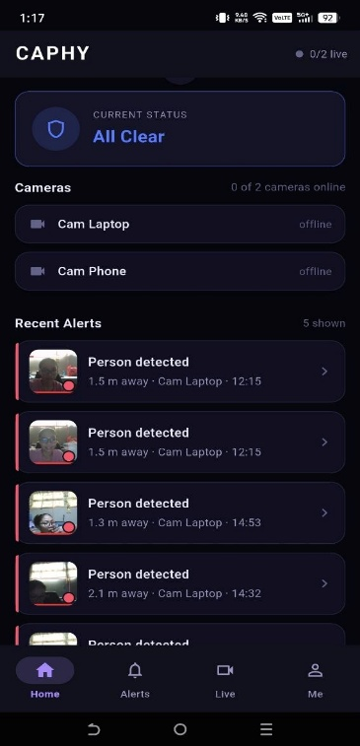
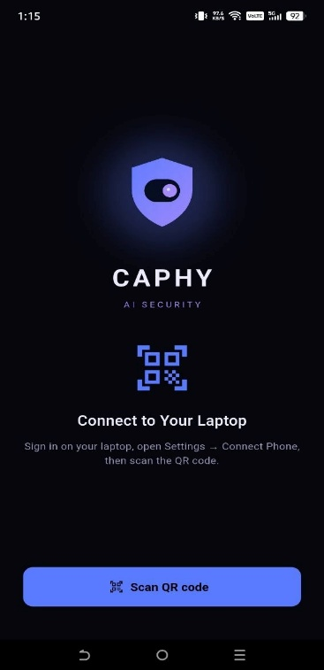
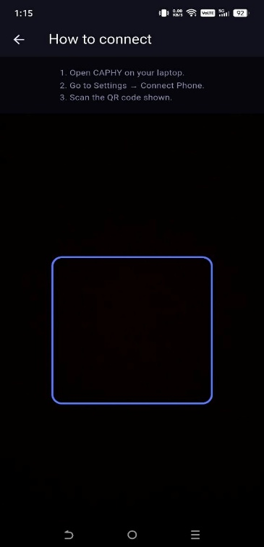
- API and Interface Specifications

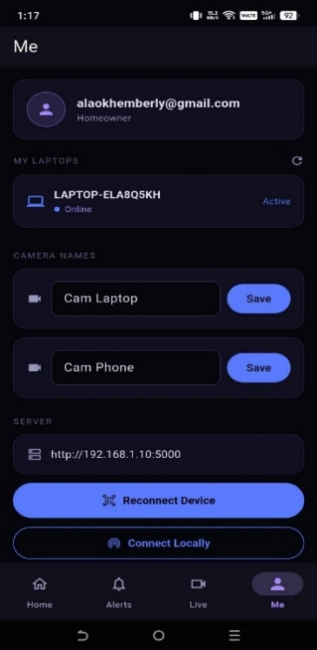
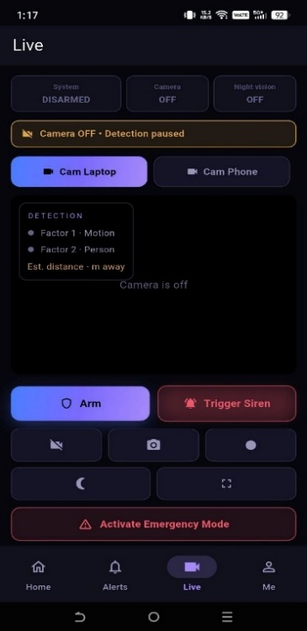
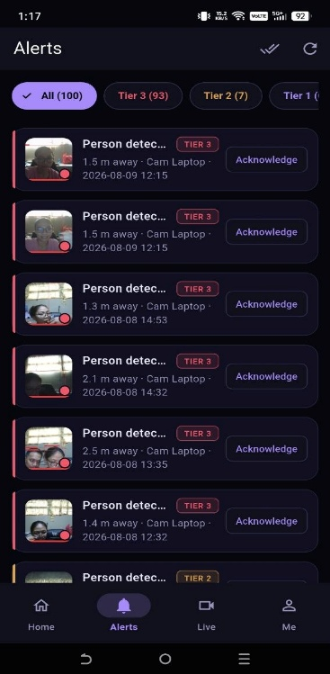



Figure 6. CAPHY App (Flutter with Firebase Cloud Messaging)
Figure 6 illustrates the CAPHY App, a custom-built mobile application developed with Flutter that serves as the primary remote-monitoring channel. The app shares the same modern dark-navy security theme as the web dashboard for a consistent experience across devices. When the host is online, the system pushes an immediate warning with a compressed image snapshot to the user’s mobile device through Firebase Cloud Messaging whenever a threat is validated, following the Three-Tier response, and follows with a video clip when the tier calls for it and bandwidth allows. Because the app is developed and maintained by the researchers rather than a third-party consumer messaging provider, alerts are delivered through CAPHY’s own application and media is kept in Firebase Storage under the owner’s account. Within the local network, the app can also open the live MJPEG camera view served by the Flask backend, for each camera independently.


Figure 7. Vosk API
Figure 7 details the Vosk API (locally hosted), which handles the system’s acoustic processing. It performs Tagalog/English speech-to-text recognition on the host machine for the system’s core command set, allowing the homeowner to change the security state (for example, disarming the alarm) without routing voice data through external cloud services such as Google Assistant or Alexa. This keeps private voice data on the local device and keeps core voice control usable during internet outages.

- Project Design
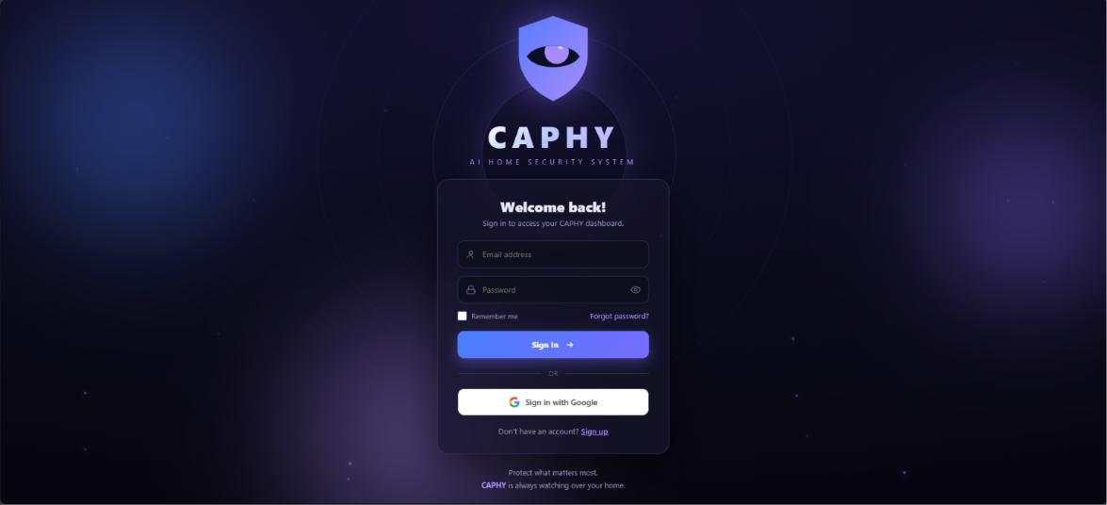

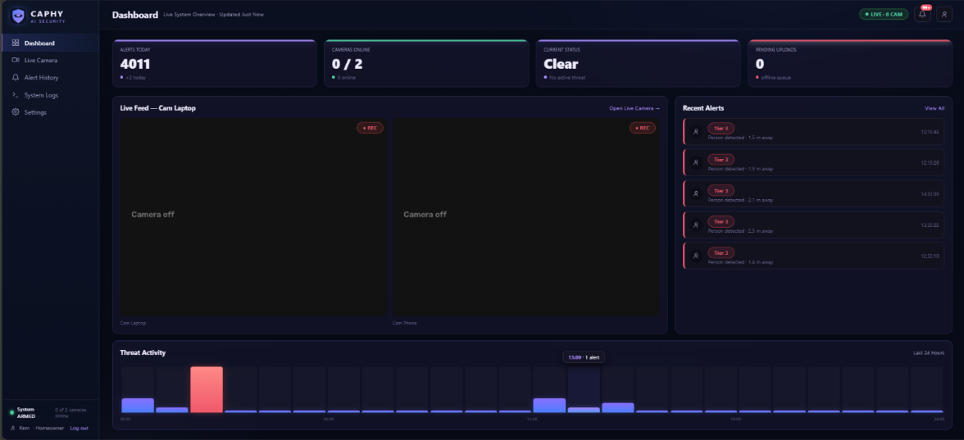

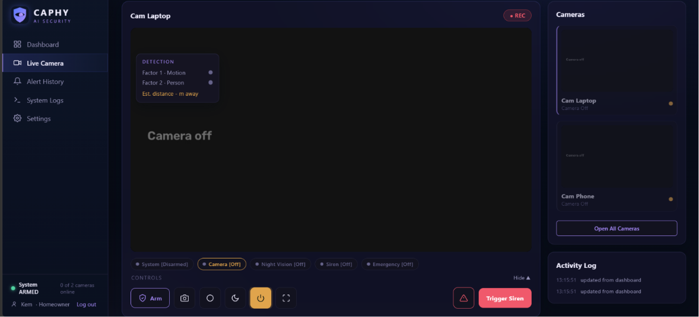

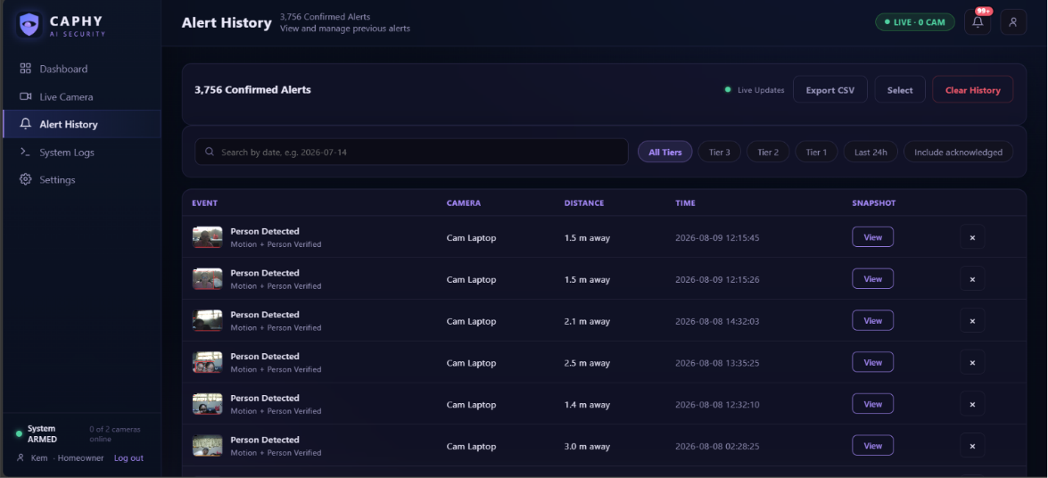

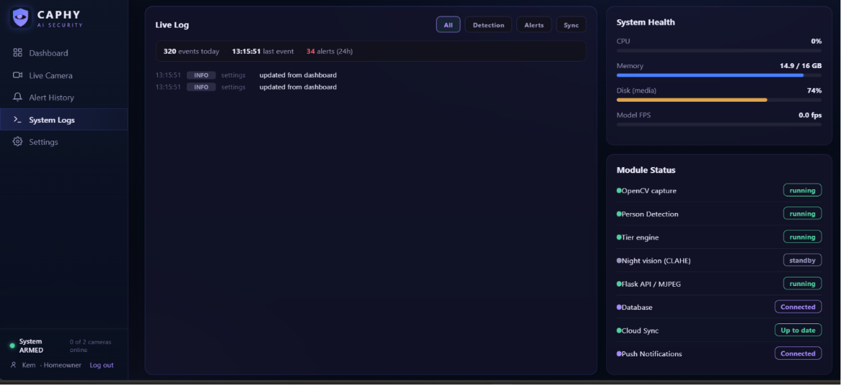

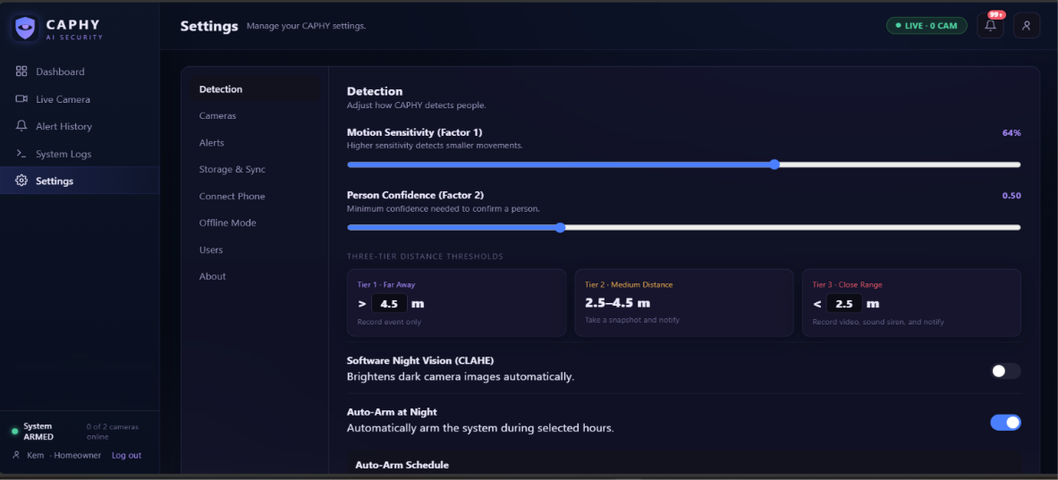

For the system-design phase, the researchers will use HTML and CSS to construct the front-end interface of the local dashboard, served by the Flask backend, while the mobile companion interface is built with Flutter. To ensure engagement and visual clarity, a deliberate, minimalist color palette will be implemented, suited to the system’s edge-lit, dark-mode aesthetic: a dark-navy background, slate-blue cards with subtle glass morphism, electric-blue accents, and teal highlights. The user interface will be mapped out prior to full development to provide an intuitive experience and mitigate usability errors. By the end of this phase, the researchers will have established a comprehensive blueprint of the system’s features and internal front-end structure.

Diagrams
To visualize the system’s infrastructure and data handling, the following diagrams will be developed:

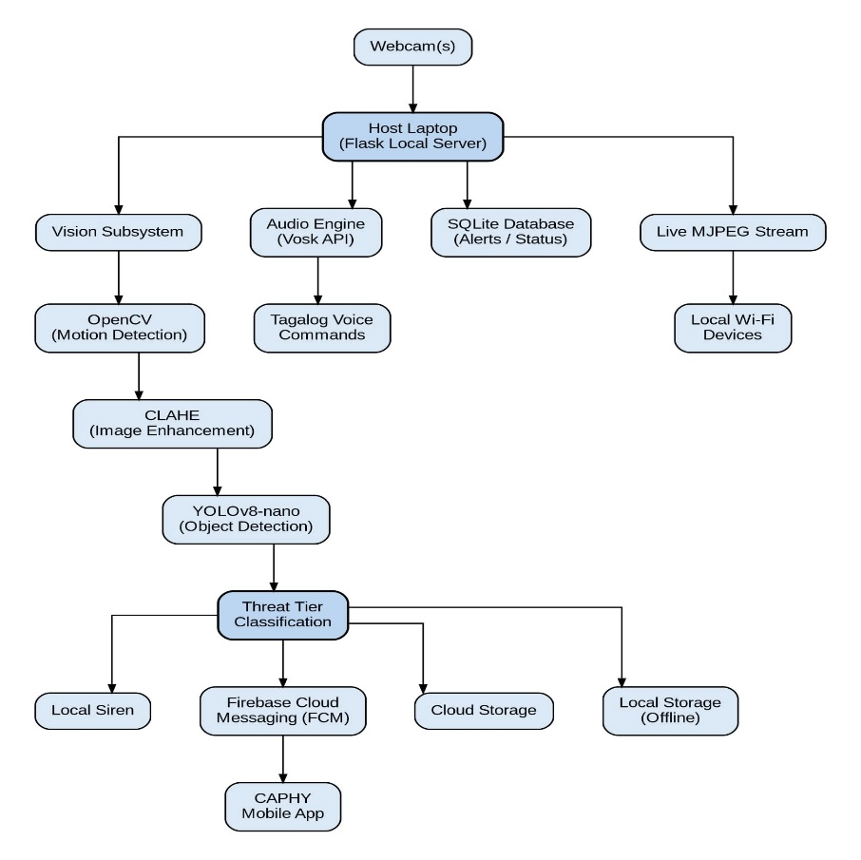
- System Architecture

Figure 8. System Architecture
Figure 8 illustrates CAPHY’s localized processing architecture. Hardware inputs (two independently controlled cameras and a microphone) feed directly into the host laptop, where a Flask-based local server coordinates the subsystems. Inside, the vision subsystem uses OpenCV for initial motion detection and CLAHE low-light enhancement, waking YOLOv8-nano only for human validation and proximity-based tier classification stabilized by distance smoothing and hysteresis. Concurrently, the audio subsystem processes Tagalog commands via the Vosk API. Validated threats trigger the local siren and dispatch tiered alerts through Firebase Cloud Messaging to the CAPHY App, while captured evidence is synced to Firebase (Firestore and Storage) when online and stored locally in compressed form when offline. Live viewing is served as an MJPEG stream on the local network per camera, and voice commands manage arming, disarming, and siren acknowledgment. This structure provides resilient, locally-processed security with hybrid storage.

- Data Flow Diagram — Context Level 0
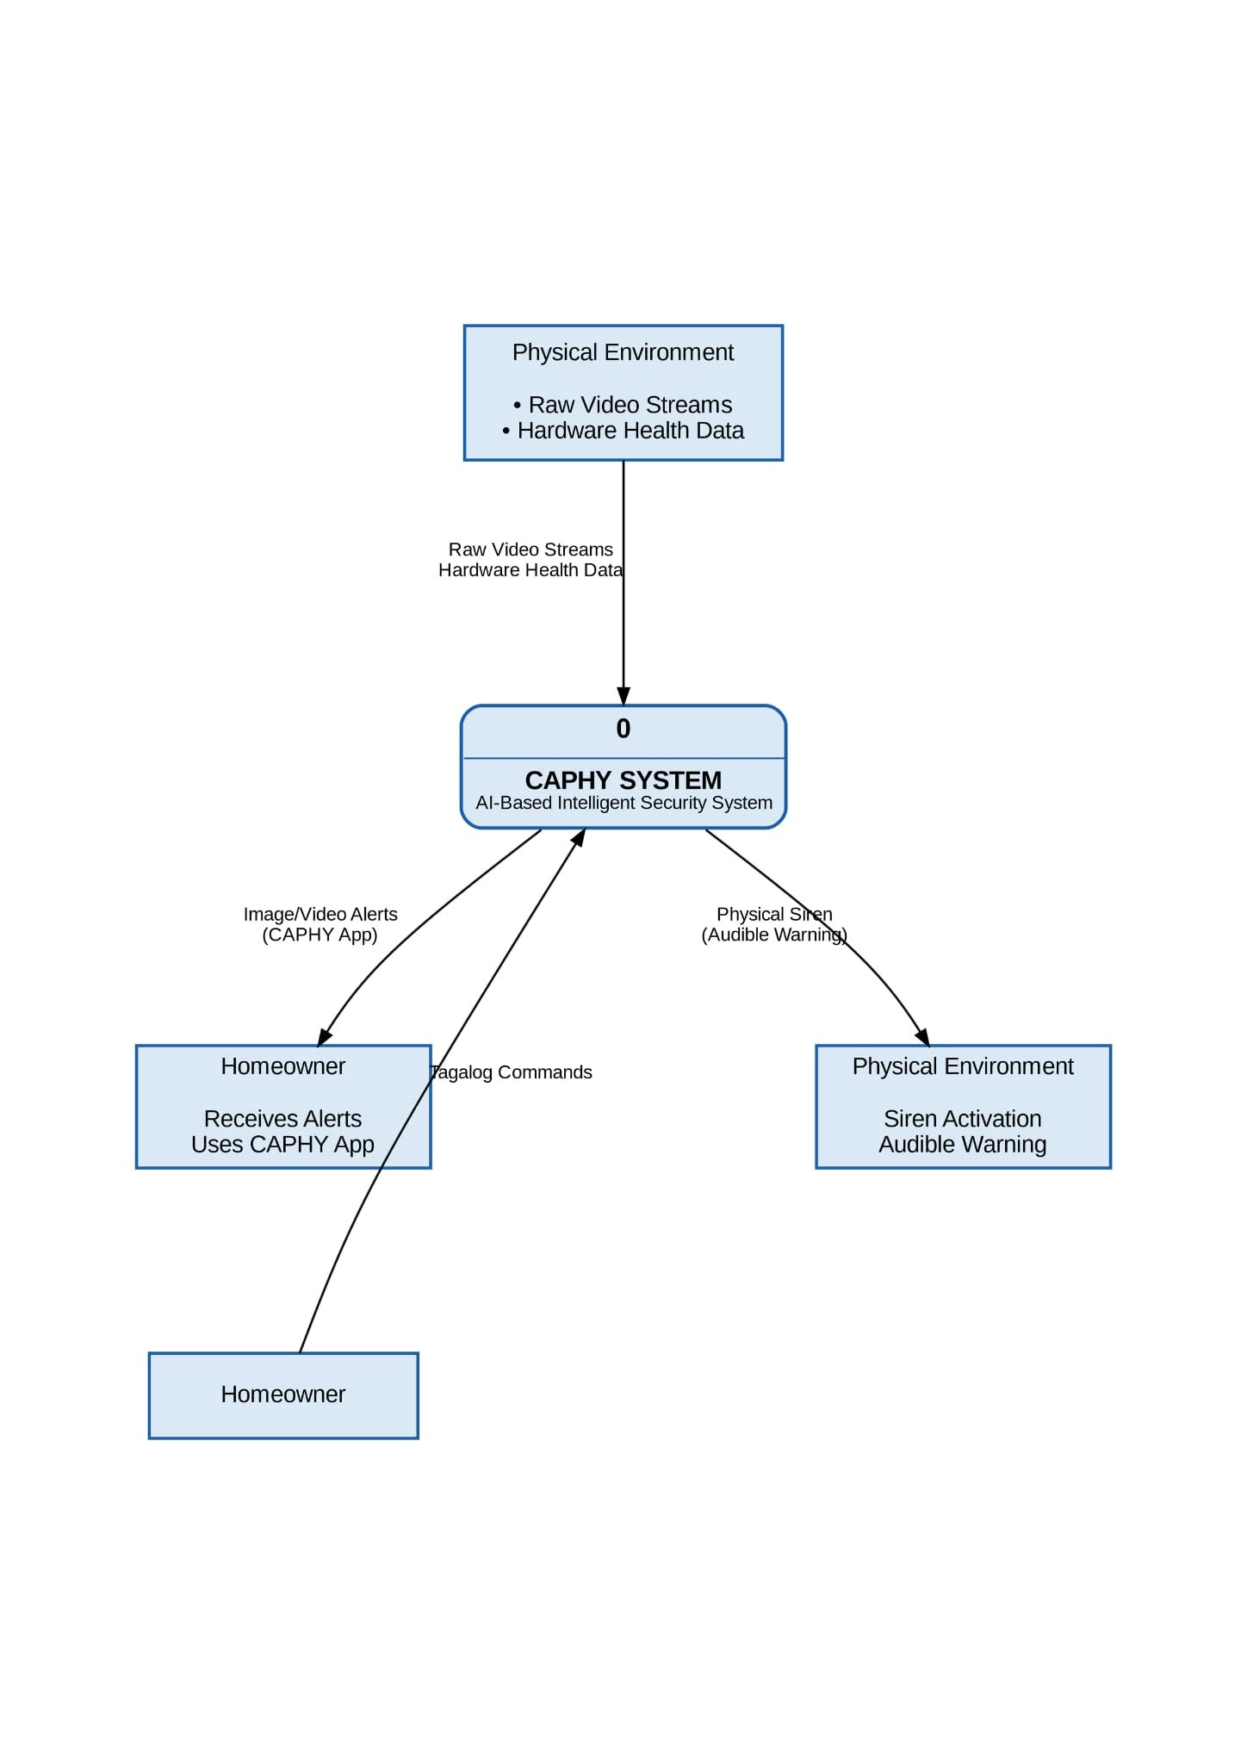

Figure 9. Data Flow Diagram (Context Level 0)
Figure 9 illustrates the Context Level 0 Data Flow Diagram, establishing the boundaries of the CAPHY system. The central security core receives “Raw Video Streams” and “Hardware Health Data” from the physical environment, alongside “Tagalog Commands” from the homeowner. Upon processing, the system outputs a “Physical Siren” signal back to the environment and dispatches “CAPHY App Image/Video Alerts” to the homeowner. This high-level model demonstrates CAPHY’s data loop, in which video processing remains localized while alerts and evidence follow the hybrid storage path.

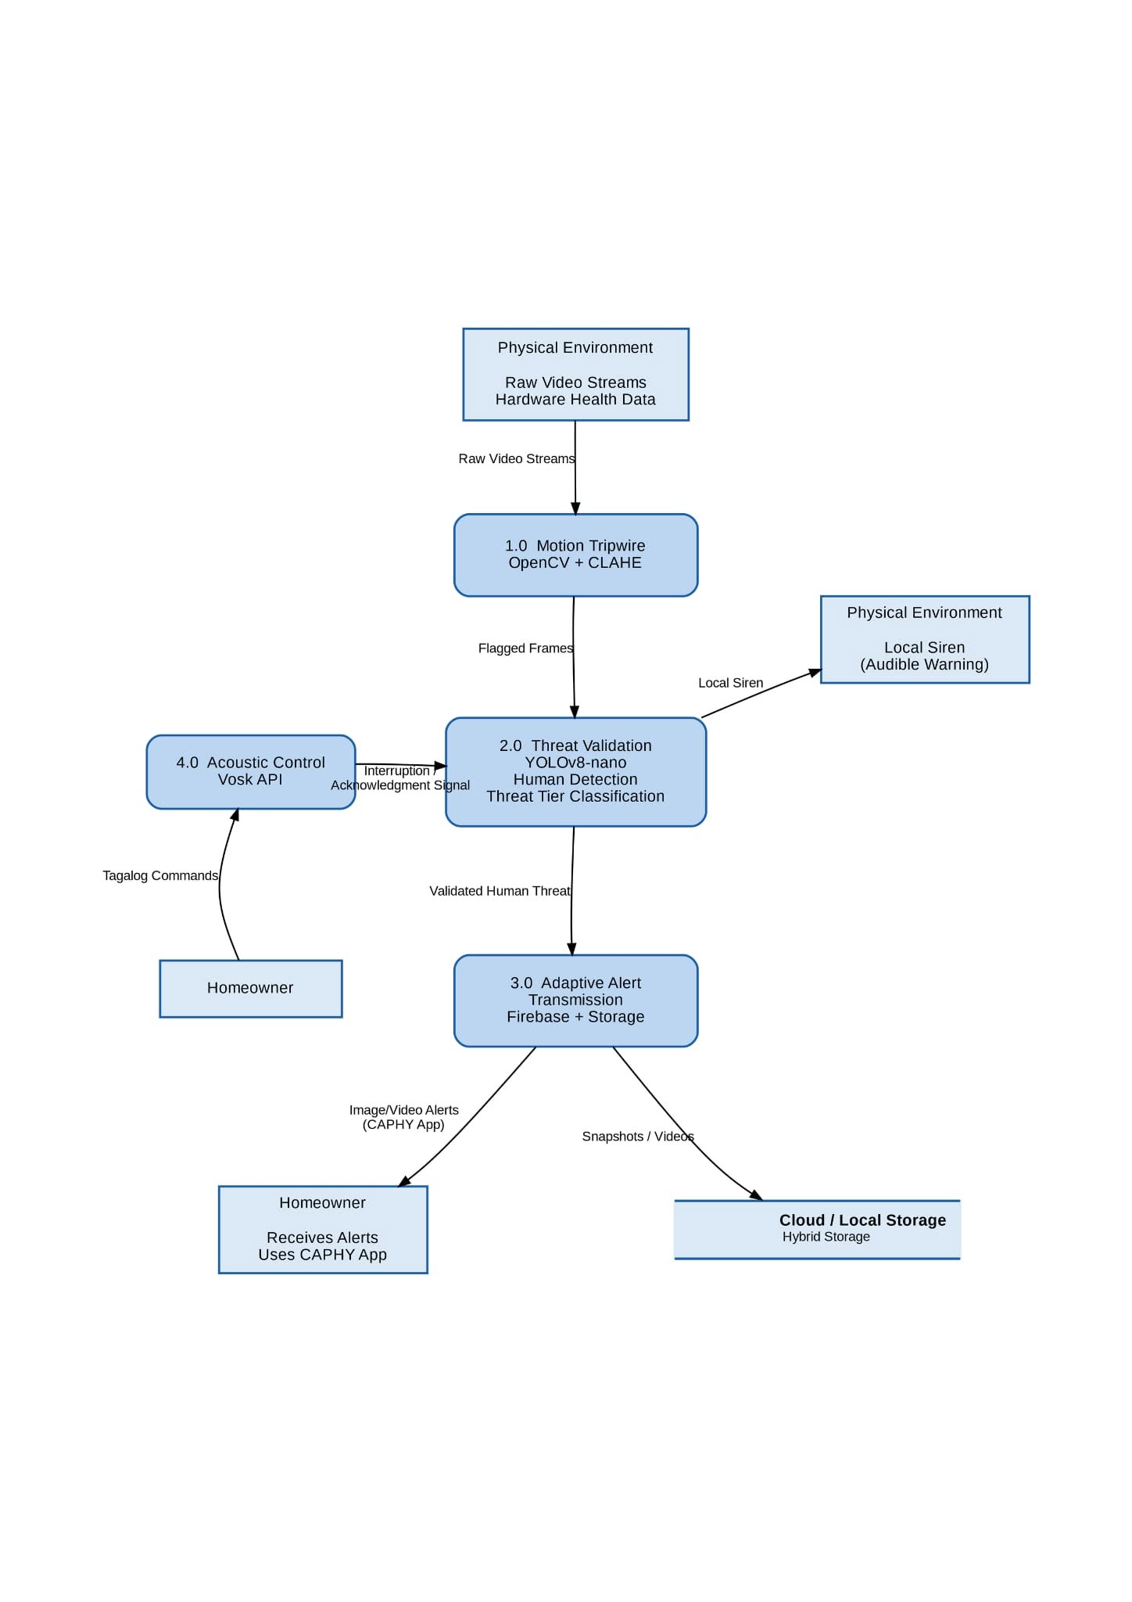
Data Flow Diagram — Context Level 1

Figure 10. Data Flow Diagram (Context Level 1)
Figure 10 details the Context Level 1 Data Flow Diagram, decomposing CAPHY’s central core into four sub-processes. “Raw Video Streams” enter Process 1.0 (Motion Tripwire – OpenCV), which passes only “Flagged Frames” to Process 2.0 (Threat Validation – YOLOv8-nano). Upon confirming a human shape and its proximity tier, Process 2.0 can trigger the local siren and forwards the “Validated Human Threat” to Process 3.0 (Adaptive Alert Transmission), which dispatches “CAPHY App Image/Video Alerts” through Firebase Cloud Messaging according to the Three-Tier response and current network condition, syncing to Firebase or compressed local storage. Concurrently, Process 4.0 (Acoustic Control – Vosk API) handles “Tagalog Commands,” sending an “Interruption/Acknowledgment Signal” back to Process 2.0 to arm, disarm, or silence the siren.

- Proposed Flowchart
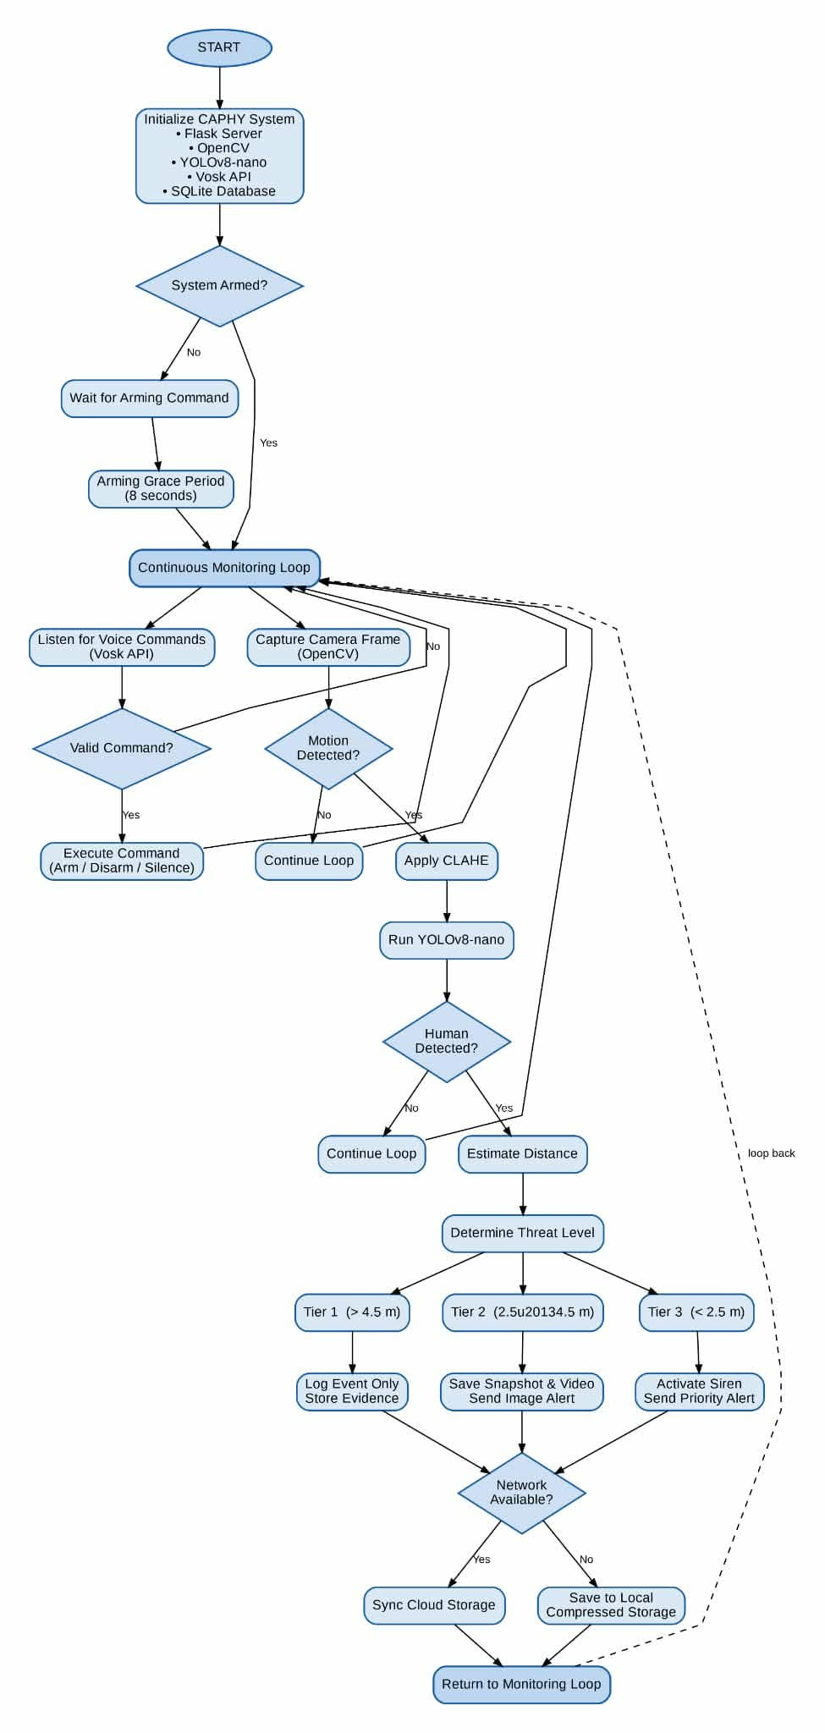

Figure 11. Flowchart
Figure 11 illustrates the logical flowchart of the CAPHY system. Operating on a continuous loop, the core engine monitors audio and visual inputs simultaneously. On the audio path, the Vosk API processes offline voice commands to arm or disarm the system and to acknowledge an active siren. On the vision path, the system executes Two-Factor Motion Validation: OpenCV serves as the initial motion tripwire (with CLAHE enhancement applied in low light), which only triggers YOLOv8-nano when the motion threshold is broken. If YOLO confirms a human presence, the system classifies the threat by proximity tier and responds accordingly — a snapshot and notification beyond 4.5 meters, adding a video clip between 2.5 and 4.5 meters, and adding the siren within 2.5 meters — before returning to its monitoring loop. When the system is in Armed mode, any confirmed detection is routed directly to the full Tier 3 response regardless of distance. A short arming grace period suppresses the siren immediately after arming, and a brief camera warm-up period after startup suppresses detection output until the feed has stabilized, so the user is not alarmed by their own presence or by a settling camera.

- Unified Modeling Language (UML) Use Case
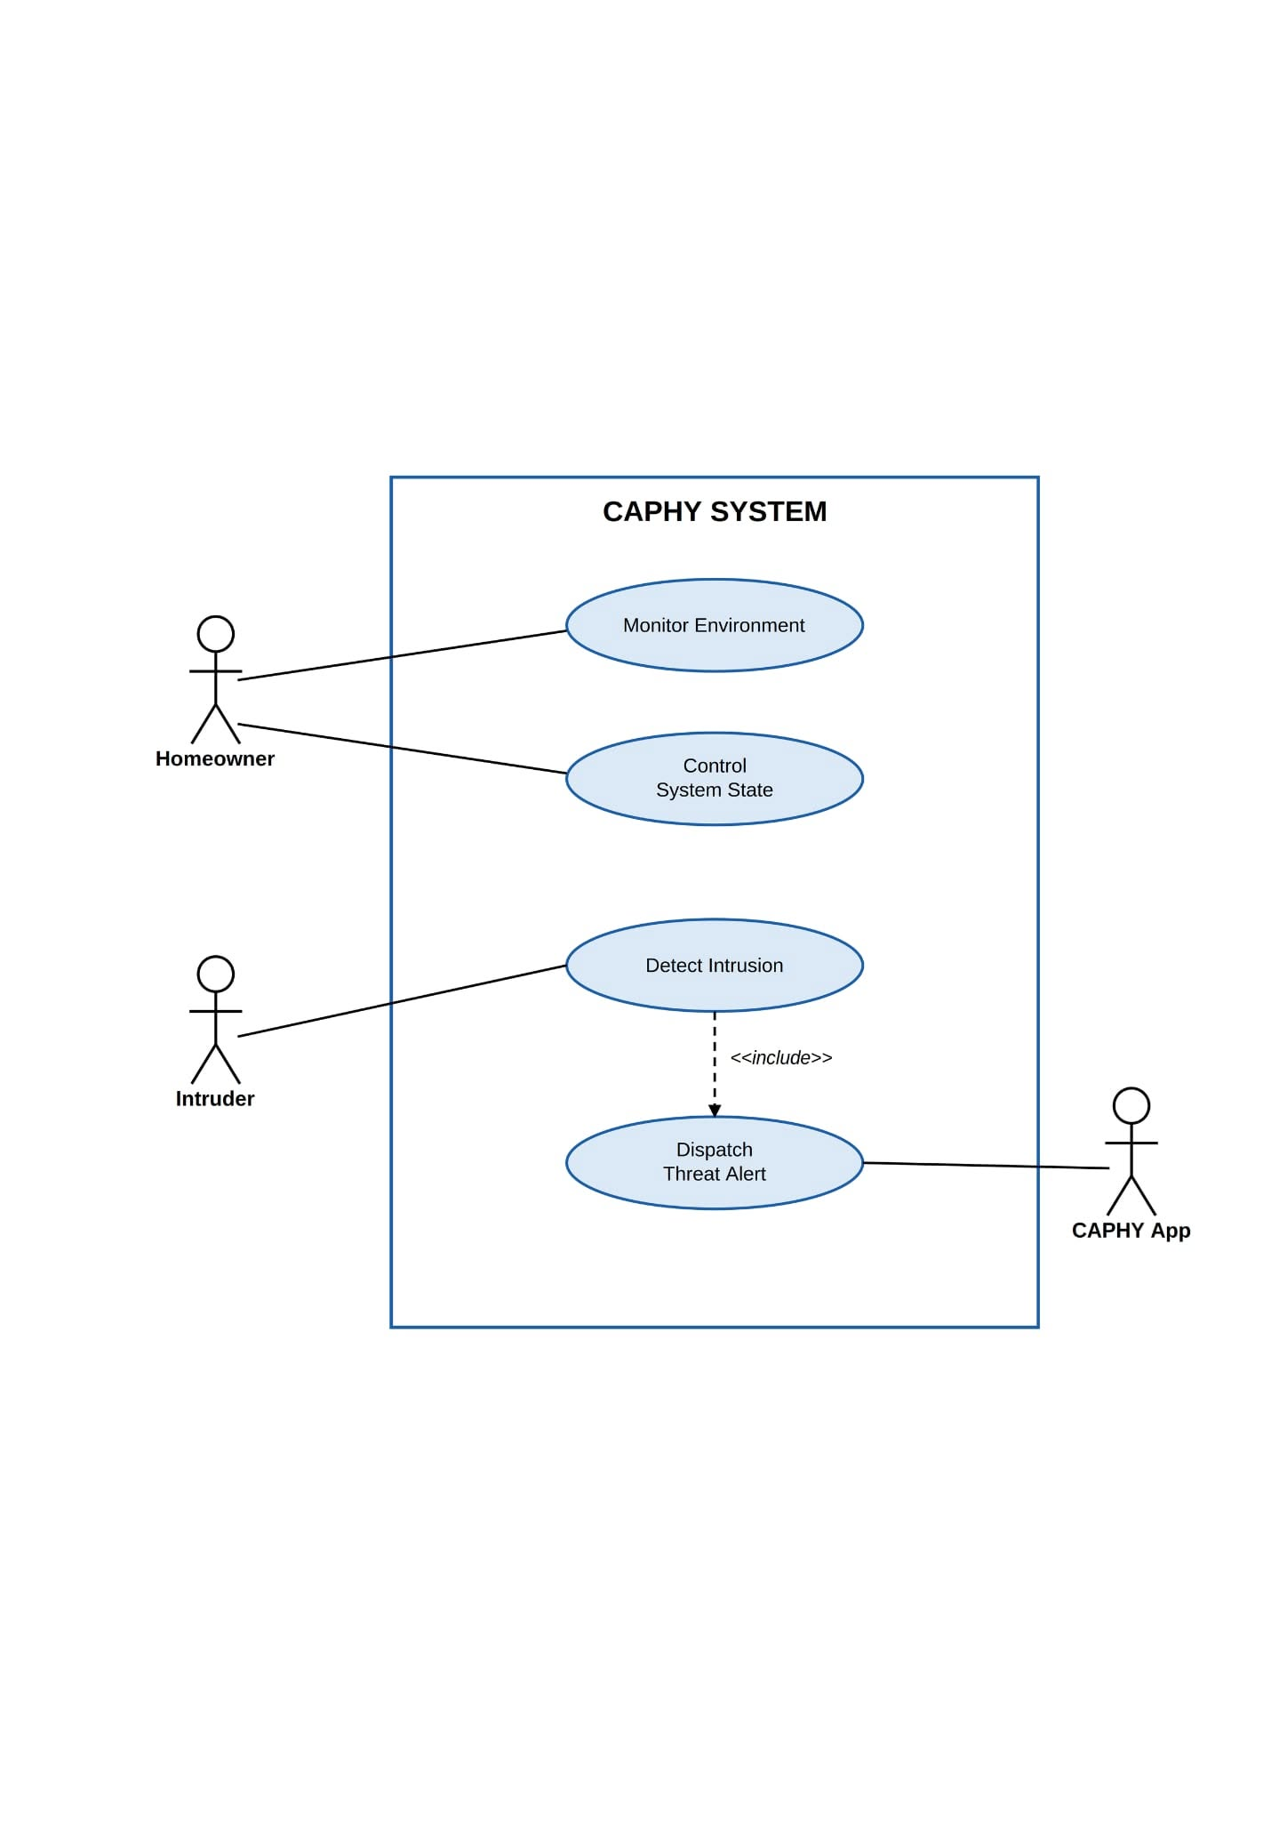

Figure 12. UML Diagram (Use Case)
Figure 12 illustrates the UML Use Case Diagram, defining the system’s functional requirements through the interactions of three primary actors: the Homeowner, the Intruder, and the CAPHY App. The Homeowner acts as the authorized user to “Monitor Environment” and “Control System State.” The Intruder serves as the external catalyst for the “Detect Intrusion” use case. A critical dependency exists between “Detect Intrusion” and “Dispatch Threat Alert,” facilitated by the CAPHY App so the Homeowner receives remote notifications. This diagram highlights the goal-oriented behavior of CAPHY from an end-user perspective.

- Database Structure
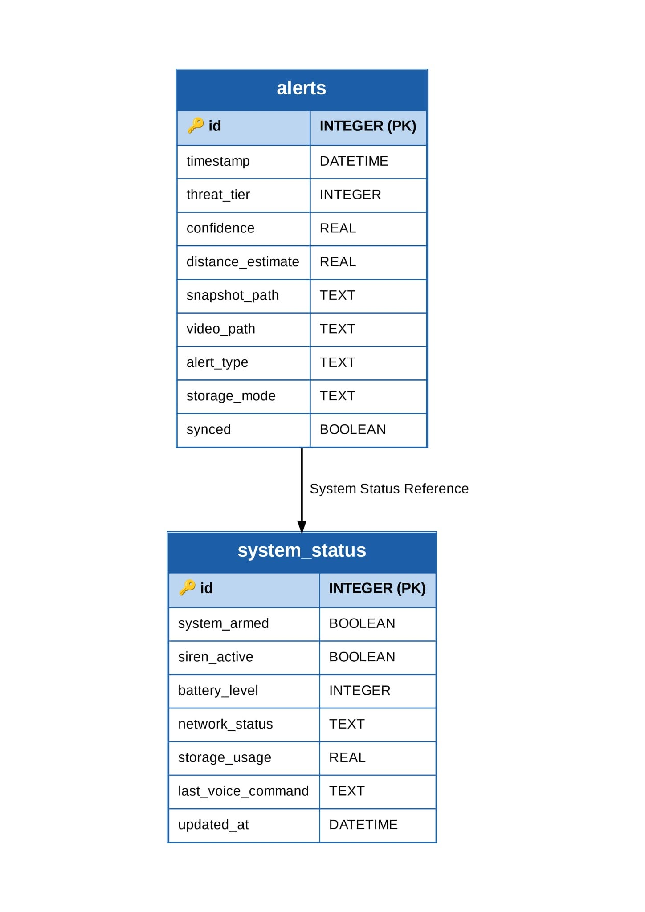

Figure 13. Database Structure
Figure 13 illustrates the local SQLite database structure, composed of the alerts and system_status tables. It stores the security-event history, including timestamps, assigned threat tier, snapshot and video file references, and system-status entries such as arming state and battery level, ensuring that event records are preserved even during internet or power outages.

- System Development
During the development phase, the researchers will iteratively construct the CAPHY system. To ensure the prototype is fully functional and optimized for the repurposed hardware, continuous unit testing will be conducted alongside the integration of the AI models (OpenCV, YOLOv8-nano, and Vosk), the Flask backend, and the CAPHY App. The backend and its REST API contract will be finalized before the dashboard and mobile interfaces are built against it, and the voice and calibration modules will be attached last. This agile approach allows the researchers to identify anomalies, resolve false-positive triggers, calibrate the tier thresholds through real distance testing, and refine the source code prior to the final evaluation.

Algorithm Discussions
Table 3:
Comparison of System Algorithms
Algorithm | Strengths | Weaknesses
OpenCV (Frame Differencing) | Consumes minimal CPU power, keeps the heavier AI dormant to optimize resource use, and processes video streams in real time. | Sensitive to sudden lighting changes (e.g., passing shadows) and cannot differentiate object types on its own.
YOLOv8-nano | Enables accurate, data-driven human detection and substantially reduces false-positive alerts and alert fatigue. | Generates significant computational load and heat if left running continuously without a primary motion trigger.
Vosk API | Performs voice recognition on-device for core commands, keeping voice data local and adapting to Tagalog speech. | Depends on clear acoustic input and lacks fluid, conversational interaction.

To fully understand the role of these algorithms within the localized architecture, their features, functions, and uses are detailed below:
- OpenCV (Open-Source Computer Vision Library)
Features: OpenCV is a lightweight, open-source computer-vision library. In this system it uses a frame-differencing feature that calculates pixel changes between consecutive frames to detect movement, and applies CLAHE (Contrast Limited Adaptive Histogram Equalization) low-light enhancement to keep the feed usable in dim conditions. Function: It functions as the system’s Level 1 motion tripwire and primary power gatekeeper. Because it requires very little CPU power, it is the only vision algorithm that runs continuously in the background. Uses: It monitors the environment for initial movement. Its primary use is to prevent the laptop from overheating (thermal throttling) by keeping the heavier YOLO model dormant until OpenCV confirms that physical motion has actually occurred.

- YOLOv8-nano (You Only Look Once, Version 8)
Features: YOLOv8-nano is a real-time object-detection model. The “nano” architecture is used because it is optimized for local processing, meaning it can run on a repurposed laptop CPU without an external GPU or cloud servers. Function: It functions as the Level 2 threat validator. Once awakened by OpenCV, it scans the flagged frames to classify the object, drawing bounding boxes and computing confidence scores for human silhouettes, and uses the bounding-box height as a proximity proxy for the 3-Tier Threat Level, with smoothing and hysteresis to keep the tier steady. Uses: It is used to reduce alert fatigue. By filtering out non-human motion (such as swaying trees, pets, or shadows), YOLOv8-nano ensures that the local siren and CAPHY App alerts are triggered only when a legitimate human presence is validated.

- Vosk API
Features: Vosk is a continuous speech-recognition toolkit that features offline acoustic modeling. It includes a Tagalog-capable language model that processes speech on the local device. Function: It functions as the system’s offline-capable voice engine. It listens to microphone input and converts Tagalog/English commands into actionable text strings, using a multi-turn dialogue protocol to confirm commands before execution. Uses: It allows the homeowner to control the system — for example, disarming the alarm by saying “CAPHY, patayin ang alarm” — without routing private voice data through third-party cloud servers. This keeps voice data on the device and keeps core control usable during ISP outages or typhoons.

CHAPTER IV
RESULTS AND DISCUSSION
This chapter presents the implementation, results, testing, and evaluation of CAPHY: An AI-Based Intelligent Security System with Two-Factor Motion Validation and Monitoring Protocols. It covers the system's technical implementation, the outputs produced by the developed prototype, the results of functionality and accuracy testing, the statistical analysis of the ISO/IEC 25010 evaluation survey, a discussion of these findings in relation to the study's objectives, and a summary connecting these results to the conclusions and recommendations presented in Chapter V.

4.1 Implementation Details
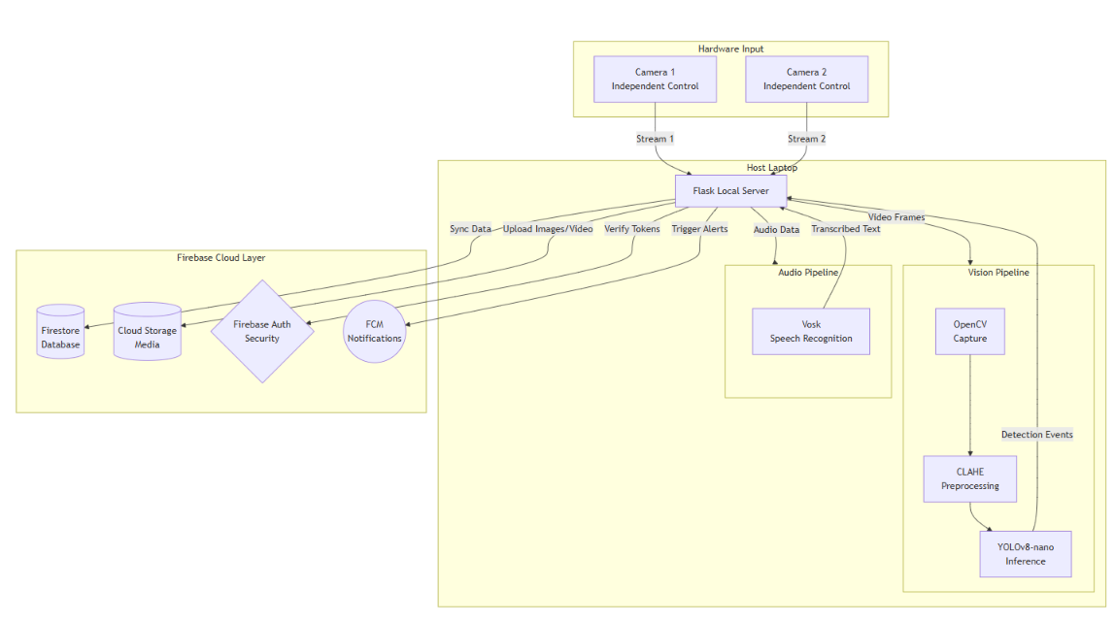
4.1.1 System Architecture

Figure 4.1 System Architecture Diagram
CAPHY follows a layered client-server architecture in which the repurposed host laptop runs the entire intelligence stack locally, while the CAPHY App and a browser-based dashboard serve as thin clients. The Flask backend exposes a REST API and an MJPEG endpoint for each camera; it does not depend on a remote server to perform
detection. The vision subsystem sits between the camera inputs and the alerting layer: OpenCV performs continuous frame-differencing motion detection, CLAHE brightens
frames captured in low light, and YOLOv8-nano is invoked only after motion is flagged, to confirm whether the detected movement is a person. Once a person is confirmed, the Threat Tier Classification module estimates distance from the bounding-box height and assigns a tier, which the Adaptive Alerting layer then routes to the local siren, to Firebase Cloud Messaging for the CAPHY App, and to Firebase Storage or local compressed storage depending on connectivity. A parallel audio subsystem processes Tagalog and English commands offline through the Vosk API to arm, disarm, or acknowledge the siren. SQLite maintains a local, always-available log of every event so that no record is lost if connectivity drops.

4.1.2 Technologies and Tools Used

Table 4.1
Technologies and Tools Used in CAPHY
Technology/Tool | Purpose | Justification
Python 3.10+ | Core application language for the vision, audio, and server logic | Mature ecosystem for computer vision and AI, and runs efficiently on standard CPUs without requiring a GPU
Flask | Local REST API and MJPEG live-stream server | Lightweight framework well suited to running on a repurposed laptop without added overhead
OpenCV | Frame-differencing motion detection and CLAHE low-light enhancement (Factor 1) | Computationally inexpensive relative to deep-learning approaches, making it suitable as an always-on tripwire
YOLOv8-nano (Ultralytics) | Real-time human detection and proximity-tier estimation (Factor 2) | Nano variant is optimized for CPU inference, keeping accuracy high while avoiding thermal throttling
Vosk API | Offline Tagalog/English speech recognition for voice commands | Performs recognition entirely on-device, keeping voice data local and functional without internet
SQLite | Local event and system-status logging | Serverless, file-based database that preserves records during internet or power outages
Flutter | Cross-platform CAPHY mobile companion app | Single codebase for the mobile client, consistent with the system's dark-navy security theme
Firebase (Firestore, Storage, Auth, FCM) | Cloud event records, media storage, user accounts, and push notifications | Managed backend that removes the need to operate a dedicated cloud server, while keeping alerts within the researchers' own configured project
Visual Studio Code | Primary IDE for backend, vision, and dashboard code | Lightweight performance and efficient Python debugging

4.1.3 Development Environment
Table 4.2
Development Environment Specifications
Component | Specification
Operating System | Windows OS (host/server)
IDE | Visual Studio Code
Processor | Intel Core i3 / Ryzen 3 or higher (repurposed laptop, CPU-only)
RAM | 4 GB to 8 GB
Storage | 256 GB solid-state storage minimum
Camera Input | Two independently controlled cameras (USB webcam, Bluetooth-connected camera, or smartphone via companion app), 960 × 480 resolution
Testing Environment | University laboratory setting, complemented by a house setting for residential-condition simulation (day/night, lights on/off)

4.1.4 System Modules
The completed system is organized into the following major modules:
Vision Module — Runs OpenCV frame-differencing continuously; hands off flagged frames to YOLOv8-nano only when motion is detected, then estimates the person's distance for tier classification, applying frame-to-frame smoothing and hysteresis to prevent tier flicker.
Camera Module — Manages two independently controlled camera feeds. Each camera can be opened or closed on its own, includes a short warm-up period on startup to prevent false alerts before the feed stabilizes, and streams via MJPEG to the local dashboard and CAPHY App.
Audio Module — Runs the Vosk API continuously in the background, listening for a defined set of Tagalog/English security commands and using a multi-turn confirmation step before executing sensitive actions such as disarming.
Alerting Module — Classifies confirmed detections into the Three-Tier response (snapshot+notify, +video, +siren) or, when the system is in Armed mode, escalates every confirmed detection directly to the full Tier 3 response.
Storage & Sync Module — Writes every event to the local SQLite database immediately, then syncs snapshots, video, and event metadata to Firebase (Firestore and Storage) when online, retaining a background retry queue to mark items as synced once the upload completes.
CAPHY App (Flutter) — Receives push alerts through Firebase Cloud Messaging, displays a merged Alert History with a live 'new alert' banner, and allows the homeowner to view cameras, arm/disarm the system, and trigger the siren remotely.
Local Dashboard (Flask/HTML/CSS) — Provides the same monitoring and control functions as the app from a browser on the local network, including system logs and settings for detection sensitivity, camera assignment, and auto-arm scheduling.

4.1.5 Algorithms and Methods
The core detection logic implemented in CAPHY is summarized in the following pseudocode, corresponding to the Two-Factor Motion Validation and Three-Tier alerting logic described in Chapter III:
LOOP every frame: motion = OpenCV.detect_frame_difference(frame) IF motion == False: CONTINUE enhanced_frame = CLAHE.apply(frame) // only if low-light mode active detections = YOLOv8n.predict(enhanced_frame) IF 'person' NOT IN detections: CONTINUE distance = estimate_distance(bounding_box_height) distance = smooth(distance) // frame-to-frame smoothing tier = classify_tier(distance, hysteresis_margin) IF system.armed_mode == True: tier = TIER_3 dispatch_alert(tier) // snapshot -> +video -> +siren, by tier log_event(tier, distance, timestamp) IF network.online: sync_to_firebase() ELSE: queue_local_compressed_storage()

4.2 Results Presentation
4.2.1 System Output
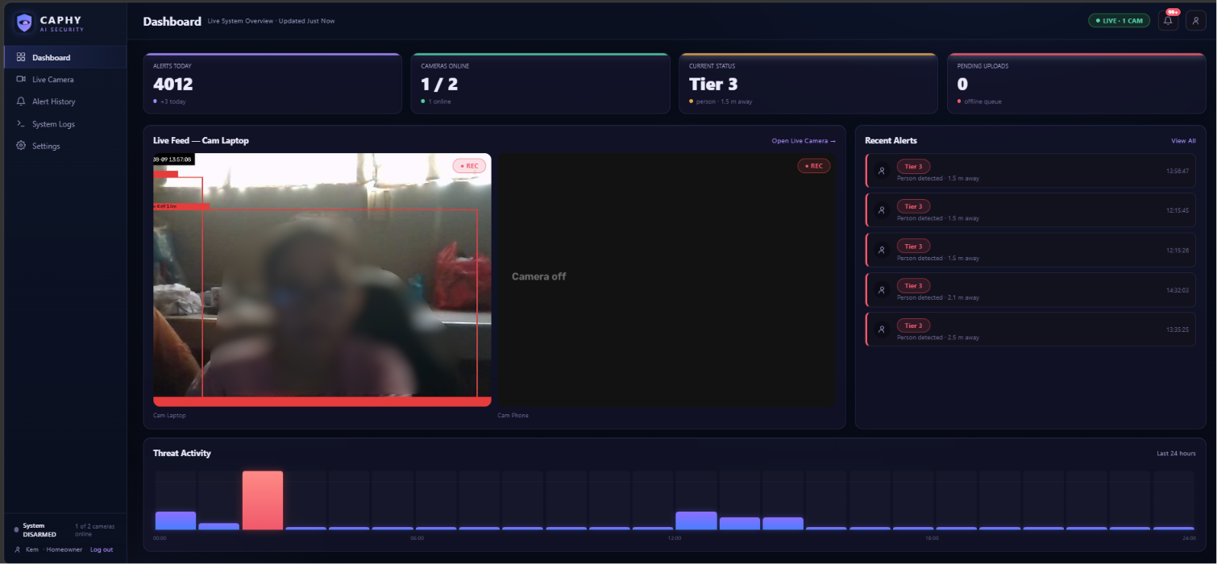Figure 4.2 CAPHY Dashboard — Overview

Figure 4.3 CAPHY Live Camera View with Two-Factor Detection Panel

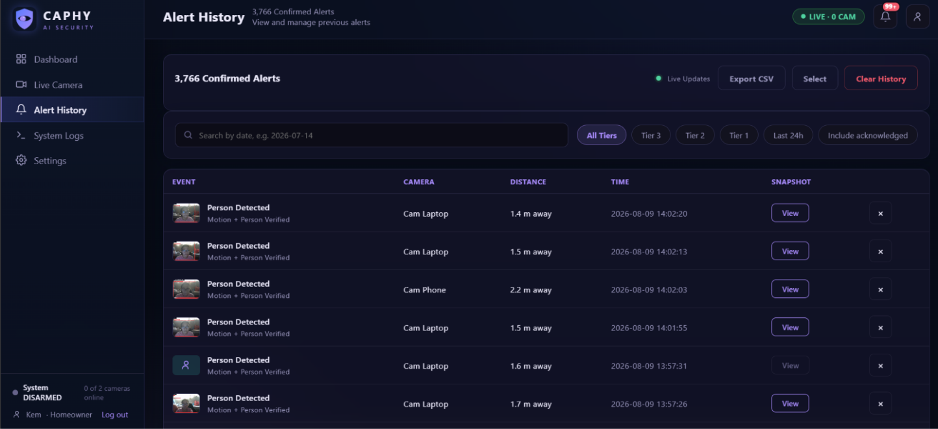
Figure 4.4 CAPHY App — Alert History

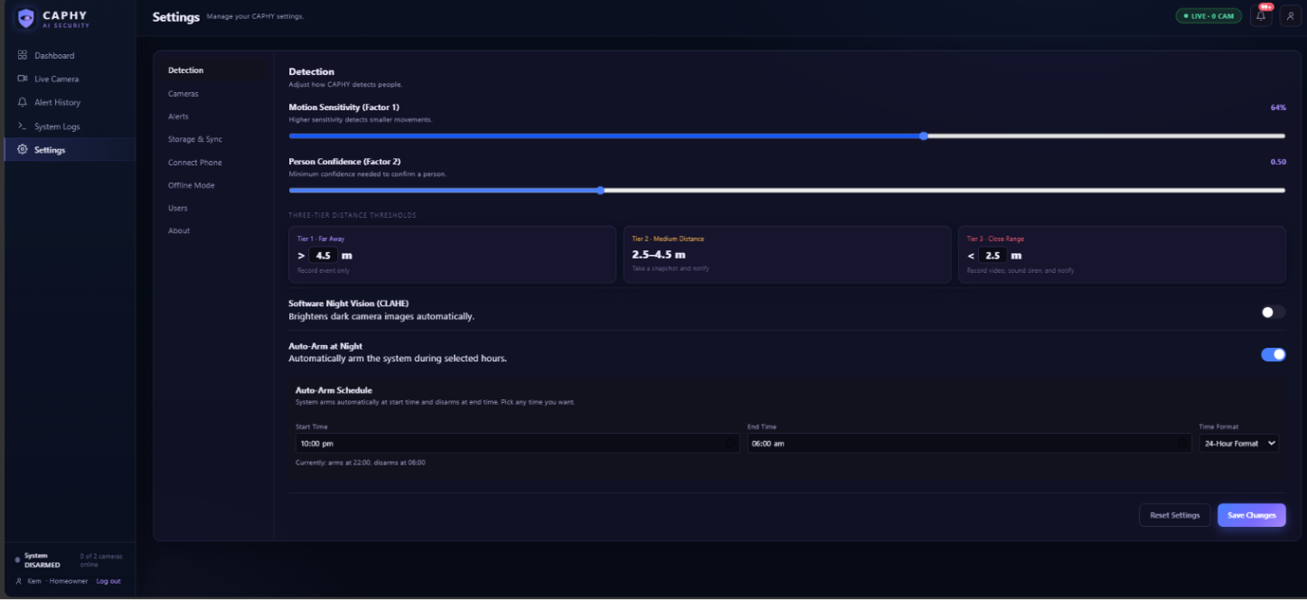
Figure 4.5 CAPHY Dashboard — Detection Settings

4.2.2 Data Visualization
Table 4.3 summarizes the outcome of the nine functional test scenarios described in Section 4.3, each repeated across five trials (45 trials total).
Table 4.3
Summary of Functional Test Case Outcomes
Test Case | Scenario | Ground Truth | Trials Passed | Result
TC001 | Empty room | No Person | 5/5 | Pass
TC002 | Person enters | Person | 5/5 | Pass
TC003 | Person exits | Person | 5/5 | Pass
TC004 | Standing person | Person | 5/5 | Pass
TC005 | Walking | Person | 5/5 | Pass
TC006 | Partial body | Person | 5/5 | Pass
TC007 | Fast movement | Person | 5/5 | Pass
TC008 | Low light | Person | 0/5 | Fail
TC009 | Non-human object | No Person | 5/5 | Pass

Table 4.4 presents the ISO/IEC 25010 category-level results from the 50-respondent evaluation survey, covering all eight software quality characteristics (Section 4.6 presents full item-level detail).
Table 4.4
ISO/IEC 25010 Category Results (n = 50)
ISO/IEC 25010 Criterion | Weighted Mean | Standard Deviation | Interpretation
Functional Suitability | 3.55 | 0.50 | Strongly Agree
Performance Efficiency | 3.43 | 0.50 | Strongly Agree
Compatibility | 3.42 | 0.50 | Strongly Agree
Usability | 3.47 | 0.50 | Strongly Agree
Reliability | 3.52 | 0.50 | Strongly Agree
Security | 3.55 | 0.50 | Strongly Agree
Maintainability | 3.53 | 0.50 | Strongly Agree
Portability | 3.50 | 0.50 | Strongly Agree
Overall | 3.50 | 0.50 | Strongly Agree

4.2.3 Performance Metrics
From the corrected confusion matrix in Section 4.3.3 (Table 4.6), CAPHY's Two-Factor Motion Validation achieved an overall accuracy of 88.9%, a precision of 100%, a recall of 85.7%, and an F1 score of 92.3% across the 45 functional test trials. Precision of 100% indicates that the system produced zero false alarms across all trials — every alert the system raised corresponded to an actual person. The shortfall in recall traces entirely to the Low Light scenario (TC008), where all five trials were missed detections, confirming the boundary condition already identified in Chapter I: CAPHY's software-based night vision (CLAHE) improves visibility in dim conditions but does not guarantee detection in very low light without added infrared hardware. On the user-acceptance side, the ISO/IEC 25010 survey (Table 4.4) returned an overall weighted mean of 3.50 (SD = 0.50) across all eight software quality characteristics, placing CAPHY's user-perceived quality within the "Strongly Agree" band of the Four-Point Likert Scale defined in Chapter III.

4.3 Testing and Evaluation
4.3.1 Testing Approach
CAPHY was evaluated through two complementary testing tracks. The first track, Functional and Accuracy Testing, verified the Two-Factor Motion Validation pipeline (OpenCV plus YOLOv8-nano) directly against ground truth using a structured confusion-matrix method: for each of nine scenarios, five trials were run, the ground truth (Person / No Person) was compared against the system's prediction, and each trial was classified as a True Positive (TP), True Negative (TN), False Positive (FP), or False Negative (FN). The second track, User Acceptance Testing, gathered structured survey feedback from fifty respondents using the ISO/IEC 25010 software-quality instrument described in Chapter III, covering all eight characteristics: Functional Suitability, Performance Efficiency, Compatibility, Usability, Reliability, Security, Maintainability, and Portability.

4.3.2 Test Cases and Scenarios
Table 4.5 lists the nine test-case scenarios executed, along with the procedure used and the expected outcome for each. Each scenario was repeated five times to reduce the influence of any single anomalous trial.
Table 4.5
Functional Test Cases and Scenarios
Test Case | Scenario | Ground Truth | Procedure | Expected Output
TC001 | Empty room | No Person | Observe for 1 minute | No Alert
TC002 | Person enters | Person | Enter frame once | Person Confirmed
TC003 | Person exits | Person | Exit frame | Person Confirmed
TC004 | Standing person | Person | Stand for 20 seconds | Person Confirmed
TC005 | Walking | Person | Walk across frame | Person Confirmed
TC006 | Partial body | Person | Half body visible | Person Confirmed
TC007 | Fast movement | Person | Run through frame | Person Confirmed
TC008 | Low light | Person | Repeat scenario in dim light | Person Confirmed
TC009 | Non-human object | No Person | Move an object for 1 minute | No Alert

4.3.3 Functionality and Performance Testing Results
Table 4.6 presents the confusion matrix compiled from all 45 trials. During review of the raw observation log, the five Low Light (TC008) trials had originally been recorded as True Positives; on re-verification against the actual test session, the system did not reliably detect the person under dim conditions in this scenario, so these five trials were corrected to False Negatives. This correction is reflected in the figures below and is the basis for the accuracy, precision, recall, and F1 score reported in this chapter.

Table 4.6
Confusion Matrix Summary (n = 45 trials)
Metric | Value
True Positive (TP) | 30
True Negative (TN) | 10
False Positive (FP) | 0
False Negative (FN) | 5
Accuracy | 88.9%
Precision | 100.0%
Recall | 85.7%
F1 Score | 92.3%
All five False Negatives originated from the Low Light scenario (TC008); every other scenario, including the two designed to trigger No Alert (Empty Room and Non-Human Object), returned a perfect result across all five trials, with zero False Positives system-wide. This pattern indicates that CAPHY's Two-Factor Motion Validation is highly effective at filtering out non-human motion — the exact behavior it was designed to achieve — but its detection reliability degrades specifically under low-light conditions, consistent with the software-only (CLAHE-based) nature of its night-vision mode.

4.4 Data Analysis
4.4.1 Statistical Analysis
Following the statistical treatment specified in Chapter III (Weighted Mean and Standard Deviation against the Four-Point Likert Scale), Table 4.7 presents the full item-level results of the ISO/IEC 25010 evaluation across all eight software quality characteristics, computed from the 50 valid, consenting respondents (45 homeowners and 5 computer laboratory personnel).

Table 4.7
Item-Level ISO/IEC 25010 Results (n = 50)
Item | Weighted Mean | SD | Interpretation
A. FUNCTIONAL SUITABILITY
1.1 Motion Detection | 3.68 | 0.47 | Strongly Agree
1.2 Threat Detection | 3.48 | 0.50 | Strongly Agree
1.3 Threat Level Classification | 3.48 | 0.50 | Strongly Agree
B. PERFORMANCE EFFICIENCY
2.1 Response Time | 3.44 | 0.50 | Strongly Agree
2.2 System Performance | 3.42 | 0.50 | Strongly Agree
2.3 Resource Utilization | 3.44 | 0.50 | Strongly Agree
C. COMPATIBILITY
3.1 Hardware Compatibility | 3.44 | 0.50 | Strongly Agree
3.2 Application Compatibility | 3.38 | 0.49 | Strongly Agree
3.3 Network Compatibility | 3.44 | 0.50 | Strongly Agree
D. USABILITY
4.1 Ease of Use | 3.48 | 0.50 | Strongly Agree
4.2 Interface Navigation | 3.40 | 0.49 | Strongly Agree
4.3 Alerts and Feedback | 3.54 | 0.50 | Strongly Agree
E. RELIABILITY
5.1 System Stability | 3.48 | 0.50 | Strongly Agree
5.2 Continuous Operation | 3.56 | 0.50 | Strongly Agree
5.3 Data Preservation | 3.52 | 0.50 | Strongly Agree
F. SECURITY
6.1 Data Protection | 3.54 | 0.50 | Strongly Agree
6.2 Secure Communication | 3.52 | 0.50 | Strongly Agree
6.3 User Confidence | 3.58 | 0.50 | Strongly Agree
G. MAINTAINABILITY
7.1 System Organization | 3.48 | 0.50 | Strongly Agree
7.2 Ease of Updating | 3.58 | 0.50 | Strongly Agree
7.3 Troubleshooting | 3.54 | 0.50 | Strongly Agree
H. PORTABILITY
8.1 Installation | 3.56 | 0.50 | Strongly Agree
8.2 Operating Environment | 3.46 | 0.50 | Strongly Agree
8.3 Deployment | 3.48 | 0.50 | Strongly Agree
Every item across all eight ISO/IEC 25010 criteria scored within the 3.38–3.68 range, placing all twenty-four items in the “Strongly Agree” band (3.26–4.00) of the Four-Point Likert Scale established in Chapter III. Standard deviations ranged from 0.47 to 0.50, indicating that while responses clustered above the midpoint of the scale, agreement was less uniform than a narrower spread would suggest; this is expected given the four-point, whole-number nature of respondent input and is consistent with genuine, unrounded survey data rather than an idealized result.

4.4.2 Hypothesis Testing
This study did not formulate directional statistical hypotheses (for example, a comparative claim requiring a t-test or ANOVA against a baseline system); its evaluation is descriptive, following the Weighted Mean and Standard Deviation model specified in Chapter III to determine overall system acceptability against the ISO/IEC 25010 standard. The overall weighted mean of 3.50 (SD = 0.50) supports the conclusion that CAPHY meets the “Strongly Agree” threshold across all eight evaluated criteria.

4.4.3 Interpretation of Results
The survey results and the functional test results tell a consistent story from two different angles. The ISO/IEC 25010 survey reflects respondents' subjective experience while operating the system directly, and it rates every one of the eight criteria — including the newly added Compatibility, Maintainability, and Portability characteristics — within the “Strongly Agree” band, with category means ranging from 3.38 (Application Compatibility) to 3.68 (Motion Detection). The independently conducted functional test, which measured detection outcomes directly against ground truth rather than through self-report, corroborates the strength of this result — 100% precision and zero false alarms — while also surfacing a limitation that a satisfaction survey alone would not have exposed as precisely: a specific, reproducible failure mode under low-light conditions. This pattern is a meaningful and expected finding rather than an anomaly, since it maps directly onto the boundary condition CAPHY's design already acknowledges: night vision achieved through CLAHE enhancement, not infrared hardware, improves but does not guarantee low-light detection.

4.5 Discussion
4.5.1 Summary of Findings
CAPHY performed strongly across both evaluation tracks. Functionally, the Two-Factor Motion Validation protocol achieved 88.9% overall accuracy across 45 trials, with 100% precision (no false alarms) and 85.7% recall, the latter limited entirely by the Low Light scenario. From the user side, all eight ISO/IEC 25010 criteria were rated “Strongly Agree” by fifty respondents, with an overall weighted mean of 3.50 out of 4.00. Together, these results directly address Specific Objectives 2 (Two-Factor Motion Validation), 3 (Monitoring Protocol via the CAPHY App), and 5 (evaluation against ISO/IEC 25010) from Chapter I, and provide supporting evidence, through the Reliability, Performance Efficiency, Compatibility, Maintainability, and Portability criteria, for Objectives 1 and 4 concerning the Repurposed Hardware Architecture and the Tagalog-capable Voice Engine.

4.5.2 Comparison with Related Work
The zero-false-positive result across all 45 trials directly supports the alert-fatigue mitigation argument made in Chapter II: because OpenCV's inexpensive frame-differencing (Singla, 2014) gates the heavier YOLOv8-nano validation (Redmon et al., 2016; Ultralytics, 2023), the system successfully avoided raising an alert for either of the two designed no-alert scenarios (Empty Room, Non-Human Object) across all ten combined trials. This is consistent with the literature's premise that two-factor validation should reduce the false positives responsible for alert fatigue (Proofpoint, 2024; IBM, 2024). The Low Light shortfall likewise matches the literature's own caveat regarding CLAHE-based enhancement: it improves contrast in existing light rather than manufacturing detail from none, so its performance is bounded in ways that infrared-equipped systems are not.

4.5.3 Strengths and Limitations
Strengths: The system demonstrated perfect precision (no false alarms) across all tested motion and no-motion scenarios, validating the core premise of Two-Factor Motion Validation. It also received uniformly favorable user ratings across all eight ISO/IEC 25010 categories, with the highest item-level scores on Motion Detection (3.68) and Ease of Updating (3.58), indicating particular respondent confidence in these areas.
Limitations: Detection reliability drops specifically in low-light conditions, the one scenario in which all five trials failed. The respondent sample was composed of 45 homeowners and 5 computer laboratory personnel (50 total); because computer laboratory personnel made up only 10% of respondents, the technical-evaluator perspective is comparatively narrow relative to the homeowner perspective, which is worth noting when interpreting the more technical criteria such as Performance Efficiency, Compatibility, Maintainability, and Portability. Additionally, the open-ended survey questions on problems encountered, most useful features, suggested improvements, and willingness to recommend the system did not yield substantive qualitative responses (a small number of brief entries such as "none" or "wala" were recorded, but no respondent described a specific pain point, feature preference, or improvement suggestion), so this chapter cannot report qualitative themes from user comments.

4.5.4 Unexpected Findings or Challenges
The most notable finding during testing and analysis was a discrepancy in the original test-observation record: the Low Light scenario (TC008) had initially been logged as five consecutive True Positives, which — combined with the corrected labeling of TC009 (Non-Human Object) from an invalid False Negative to a True Negative — would have produced a misleadingly perfect 100% accuracy, precision, recall, and F1 score. On review, it was determined that the Low Light trials had not, in fact, reliably passed, and the record was corrected to reflect five False Negatives instead. This correction is treated in this chapter as the true and reportable result, since a 100% result across every category, including a known hardware limitation (no infrared sensor), would not have
been credible or consistent with the system's documented design constraints in Chapter I. Reporting the corrected 88.9% accuracy, rather than the originally logged 100%, is considered a more defensible and honest representation of the system's actual behavior.

4.5.5 Implications of the Study
These results indicate that CAPHY's core technical proposition — filtering false alarms through a two-stage, CPU-friendly detection pipeline running on repurposed hardware — is achievable in practice and not merely in principle. The zero-false-positive result under normal and daytime conditions supports the study's rationale that alert fatigue can be meaningfully reduced without requiring cloud-based or GPU-accelerated processing. At the same time, the confirmed low-light limitation has a direct practical implication for deployment guidance: households relying on CAPHY for nighttime security should be advised, consistent with the Limitations already stated in Chapter I, that software-based night vision improves visibility but does not replace dedicated infrared hardware for full darkness scenarios, and this should be treated as a priority area for future hardware augmentation rather than a software-only fix.

4.6 User Evaluation
4.6.1 Evaluation Design
User evaluation was conducted using a structured, Google Forms-based ISO/IEC 25010 questionnaire administered after respondents interacted directly with the CAPHY system, consisting of a data privacy consent statement, respondent demographics, twenty-four rating items covering all eight ISO/IEC 25010 characteristics, and open-ended feedback questions. All 50 form submissions provided recorded consent and were retained for analysis. The 50 valid respondents comprised 45 homeowners (90%) and 5 computer laboratory personnel (10%). All fifty respondents tested CAPHY using both a laptop/desktop and a mobile phone, reflecting the system's intended dual-interface (dashboard and CAPHY App) usage pattern.

Table 4.8
Respondent Demographics (n = 50)
Category | n | Percentage
Homeowner | 45 | 90%
Computer Laboratory Personnel | 5 | 10%
Total | 50 | 100%

4.6.2 Evaluation Criteria
Respondents rated CAPHY on twenty-four items across all eight ISO/IEC 25010 criteria specified in Chapter III: Functional Suitability (motion detection, threat detection, threat level classification), Performance Efficiency (response time, system performance, resource utilization), Compatibility (hardware compatibility, application compatibility, network compatibility), Usability (ease of use, interface navigation, alerts and feedback), Reliability (system stability, continuous operation, data preservation), Security (data protection, secure communication, user confidence), Maintainability (system organization, ease of updating, troubleshooting), and Portability (installation, operating environment, deployment). Each item was rated on the Four-Point Likert Scale (1 = Strongly Disagree to 4 = Strongly Agree) defined in Table 2 of Chapter III.

4.6.3 Results of User Testing
Table 4.9 summarizes the average rating per ISO/IEC 25010 criterion.
Table 4.9
Results of User Testing by ISO/IEC 25010 Criterion
Criterion | Average Rating (1–4) | Remarks
Functional Suitability | 3.55 | Motion Detection scored the highest of all twenty-four items (3.68)
Performance Efficiency | 3.43 | System Performance scored the relative low point (3.42) of this criterion
Compatibility | 3.42 | The lowest-scoring criterion overall; Application Compatibility (3.38) was the single lowest item
Usability | 3.47 | Alerts and Feedback scored highest in this criterion (3.54); Interface Navigation was comparatively lower (3.40)
Reliability | 3.52 | Continuous Operation scored highest in this criterion (3.56)
Security | 3.55 | User Confidence scored highest in this criterion (3.58)
Maintainability | 3.53 | Ease of Updating scored highest in this criterion (3.58)
Portability | 3.50 | Installation scored highest in this criterion (3.56); Operating Environment was comparatively lower (3.46)

4.6.4 Analysis of Feedback
The quantitative results show consistently favorable acceptance across all eight criteria, with Compatibility as the relative low point (3.42) and Functional Suitability and Security as the relative high points (3.55 each); all eight nonetheless remain within the "Strongly Agree" band. However, the open-ended questions included in the instrument — covering problems encountered, the most useful feature, recommended improvements, willingness to recommend the system, and additional comments — did not yield substantive qualitative feedback: across 50 respondents, only a handful of brief, non-descriptive entries were recorded (for example, "none," "wala," and "maganda naman siya gamitin"), and no respondent provided a specific pain point, feature preference, or detailed improvement suggestion in writing. This is noted here plainly rather than inferred or fabricated. Future iterations of the survey, or a follow-up round of structured interviews, are recommended to capture the qualitative detail that a purely numeric Likert-scale instrument cannot surface — for example, why Compatibility scored comparatively lower than the other seven criteria, despite still remaining in the "Strongly Agree" range.

4.7 Summary
This chapter presented the implementation, results, and evaluation of CAPHY. The system was built around a Flask-based local server coordinating an OpenCV/YOLOv8-nano vision pipeline, a Vosk-based offline voice engine, an SQLite event log, and a Firebase-backed hybrid storage and alerting layer, with a Flutter mobile app and browser dashboard as the user-facing clients.
Functional testing across 45 trials in nine scenarios produced 88.9% accuracy, 100% precision, 85.7% recall, and an F1 score of 92.3%, with the system's only failure mode traced to the Low Light scenario — a limitation consistent with its documented reliance on software-based (CLAHE) night vision rather than infrared hardware. The ISO/IEC 25010 evaluation survey, completed by 50 valid respondents, rated CAPHY “Strongly Agree” (weighted mean 3.50 of 4.00) across all eight criteria — Functional Suitability, Performance Efficiency, Compatibility, Usability, Reliability, Security, Maintainability, and Portability — with Compatibility as the relative low point (3.42) and Functional Suitability and Security as the relative high points (3.55).
Taken together, these findings substantiate the study's Specific Objectives from Chapter I: the Two-Factor Motion Validation protocol measurably eliminated false alarms in daytime and lit conditions; the Monitoring Protocol and Repurposed Hardware Architecture were rated favorably for reliability and performance despite running on ordinary hardware; and the overall system met the ISO/IEC 25010 standard at a “Strongly Agree” level across all eight characteristics. The one substantiated limitation — reduced low-light detection reliability — together with the comparatively narrow technical-evaluator representation, the relatively lower Compatibility score, and the absence of usable open-ended feedback, are carried forward as concrete, evidence-based recommendations for further development and evaluation in Chapter V.

CHAPTER V
SUMMARY OF FINDINGS, PRESENTATION, INTERPRETATION, DISCUSSION OF RESULTS AND RECOMMENDATIONS

5.1 Introduction
This chapter presents the summary, interpretation, and discussion of the results obtained from the evaluation of CAPHY: An AI-Based Intelligent Security System with Two-Factor Motion Validation and Monitoring Protocols. The evaluation followed the research instrument and statistical treatment established in Chapter III and applied in Chapter IV, and focused on all eight ISO/IEC 25010 software-quality characteristics: Functional Suitability, Performance Efficiency, Compatibility, Usability, Reliability, Security, Maintainability, and Portability. The data gathered from fifty valid respondents, together with the results of the independently conducted functional and accuracy testing, were analyzed, summarized, and interpreted to determine the overall quality and effectiveness of the developed system. This chapter also presents the conclusions drawn from these findings and the recommendations proposed for future development.

5.2 Summary of Findings
This section summarizes the results obtained from the ISO/IEC 25010 evaluation survey and the functional testing conducted in Chapter IV, presented per criterion.
Functional Suitability — Respondents rated CAPHY's core detection functions (motion detection, threat detection, and threat level classification) at a weighted mean of 3.55, the highest-scoring criterion alongside Security. This is corroborated by the independently conducted functional test, which found 100% precision (zero false alarms) across 45 trials, directly supporting the system's core premise that Two-Factor Motion Validation filters out false threats.
Performance Efficiency — This criterion, covering response time, system performance, and resource utilization on repurposed hardware, received a weighted mean of 3.43, within the "Strongly Agree" band but below the overall average. System Performance scored the lowest individual item in this category (3.42).
Compatibility — Hardware compatibility, application compatibility, and network compatibility were rated at a weighted mean of 3.42, the lowest of the eight category means. Application Compatibility was the single lowest-scoring item across all twenty-four items (3.38).
Usability — Ease of use, interface navigation, and alerts and feedback received a weighted mean of 3.47. Alerts and Feedback scored highest in this category (3.54), while Interface Navigation was comparatively lower (3.40).
Reliability — System stability, continuous operation during offline periods, and data preservation were rated at a weighted mean of 3.52. Continuous Operation scored highest in this category (3.56).
Security — Data protection, secure communication, and user confidence were rated at a weighted mean of 3.55, tying Functional Suitability as the highest-scoring criterion. User Confidence scored highest in this category (3.58).
Maintainability — System organization, ease of updating, and troubleshooting were rated at a weighted mean of 3.53. Ease of Updating scored highest in this category (3.58).
Portability — Installation, operating environment, and deployment were rated at a weighted mean of 3.50. Installation scored highest in this category (3.56), while Operating Environment was comparatively lower (3.46).
Across all eight criteria, the overall weighted mean was 3.50 (SD = 0.50), placing CAPHY in the "Strongly Agree" band of the Four-Point Likert Scale used throughout this study. This summary is consistent with, and directly carried forward from, the detailed item-level results already presented in Chapter IV (Section 4.4.1, Table 4.7).

5.3 Presentation of Data
This section presents the quantitative results of the evaluation using the same instrument, statistical treatment, and Four-Point Likert Scale established in Chapter III. The numerical mean ranges used to interpret the results are as follows:
- Strongly Agree: 3.26 – 4.00
- Agree: 2.51 – 3.25
- Disagree: 1.75 – 2.50
- Strongly Disagree: 1.00 – 1.74

Table 5.1
Summary of ISO/IEC 25010 Evaluation Results (n = 50)
Criterion | Weighted Mean | Standard Deviation | Interpretation
Functional Suitability | 3.55 | 0.50 | Strongly Agree
Performance Efficiency | 3.43 | 0.50 | Strongly Agree
Compatibility | 3.42 | 0.50 | Strongly Agree
Usability | 3.47 | 0.50 | Strongly Agree
Reliability | 3.52 | 0.50 | Strongly Agree
Security | 3.55 | 0.50 | Strongly Agree
Maintainability | 3.53 | 0.50 | Strongly Agree
Portability | 3.50 | 0.50 | Strongly Agree
OVERALL | 3.50 | 0.50 | Strongly Agree

Table 5.2 presents the corroborating results of the functional and accuracy testing conducted independently of the survey, as detailed in Chapter IV (Section 4.3.3).

Table 5.2
Summary of Functional Test Results (n = 45 trials)
Metric | Value
Accuracy | 88.9%
Precision | 100.0%
Recall | 85.7%
F1 Score | 92.3%

5.4 Interpretation of Results
This section interprets the quantitative findings in relation to CAPHY's objectives as defined in Chapter I.
Functional Suitability (3.55, Strongly Agree) indicates that evaluators strongly agree CAPHY performs its intended job as a security system. This directly supports Specific Objective 2 (Two-Factor Motion Validation) and is reinforced by the 100% precision achieved in functional testing — across every trial, the system never raised a false alarm, meaning the OpenCV-plus-YOLOv8-nano validation pipeline behaves exactly as designed.
Performance Efficiency (3.43, Strongly Agree) scoring below the overall average, suggests that running the full AI pipeline on repurposed, CPU-only hardware is viable but is an area respondents found comparatively less strong — consistent with the Repurposed Hardware Architecture's design trade-off of favoring affordability over raw processing headroom, as discussed in Chapter I and II.
Compatibility (3.42, Strongly Agree) being the lowest-scoring criterion overall, indicates that while respondents still agreed CAPHY works properly with its supported cameras, mobile application, and network conditions, this is the area with the most relative room for improvement, particularly around Application Compatibility (3.38), the single lowest-rated item in the instrument.
Usability (3.47, Strongly Agree) reflects a positive experience with the CAPHY App and dashboard interface, supporting Specific Objective 4. The comparatively lower Interface Navigation score (3.40) relative to Alerts and Feedback (3.54) suggests that while alerts are clear, first-time navigation may leave slightly more room for improvement than day-to-day interaction.
Reliability (3.52, Strongly Agree) confirms that the Repurposed Hardware Architecture's core promise — continued operation and data integrity during power and internet interruptions — was perceived as strongly met by respondents, directly supporting Specific Objective 1.
Security (3.55, Strongly Agree) with User Confidence as the highest-rated item in this category (3.58), indicates strong respondent confidence in CAPHY's local-processing and data-protection model, consistent with the data-privacy rationale established in Chapter I and II under RA 10173.
Maintainability (3.53, Strongly Agree) indicates respondents believe CAPHY is reasonably organized, updatable, and troubleshootable, supporting the system's long-term sustainability beyond the initial capstone deployment.
Portability (3.50, Strongly Agree) indicates respondents agree CAPHY can be installed, configured, and deployed to another compatible computer with reasonable ease, supporting the system's practical reproducibility across different households.
Taken together, all eight criteria exceeded the 3.26 threshold for "Strongly Agree," with no criterion falling into the "Agree" range or below. This indicates that CAPHY meets its stated objectives at a strong level of user acceptance, while the comparatively narrower margins for Compatibility and Performance Efficiency identify the areas most likely to benefit from further optimization.

5.5 Discussion
Overall System Evaluation — With an aggregated weighted mean of 3.50 (SD = 0.50) across all eight ISO/IEC 25010 criteria, and a corroborating functional-test precision of 100% with zero false alarms, CAPHY performed favorably across both the subjective (survey) and objective (ground-truth) evaluation tracks conducted in this study. The standard deviation of 0.50 across items reflects the natural spread of a four-point, whole-number Likert instrument rather than an artificially uniform result, and no criterion fell outside the "Strongly Agree" band despite this spread.
Comparison with Related Studies — As discussed in Chapter II, the reviewed literature establishes the individual technical building blocks CAPHY relies on — single-stage detection (Redmon et al., 2016; Ultralytics, 2023), lightweight frame-difference motion gating (Singla, 2014), thermal limits of continuous CPU inference (Benoit-Cattin et al., 2020), and the human cost of alert fatigue (Proofpoint, 2024; IBM, 2024) — but does not present an integrated system evaluated end-to-end under Philippine infrastructure conditions. The zero-false-positive result obtained here provides empirical evidence, rather than only a design argument, that combining a cheap motion tripwire

with a heavier validator can achieve the alert-fatigue reduction the literature calls for.
Implications — These results support the practical viability of CAPHY's central design proposition: that a household security system built on repurposed consumer hardware, without cloud-dependent processing or a paid subscription, can achieve favorable reliability, usability, security, maintainability, and portability outcomes as judged by real users, while independently verified detection behavior confirms this is not merely a matter of favorable self-report. This has a direct real-world implication for the study's target population — Filipino households facing inconsistent power and internet access — for whom CAPHY offers an evaluated, working alternative to commercial cloud-based systems.
Recommendations for Improvement — Based on the results and limitations identified in Chapter IV, four concrete areas are recommended for further development. First, low-light detection reliability should be improved, either through infrared or supplemental hardware, or through further tuning of the CLAHE enhancement pipeline and additional low-light training data for the YOLOv8-nano model, since this was the sole source of missed detections in functional testing. Second, Compatibility, the lowest-scoring survey criterion, should be revisited, particularly Application Compatibility (3.38), through further testing across a wider range of camera hardware, mobile devices, and network conditions. Third, Performance Efficiency should be reviewed through further optimization of the detection pipeline on lower-end repurposed hardware. Fourth, future evaluation rounds should include structured qualitative data collection — for example, brief guided interviews rather than open-ended form fields — since the open-ended survey questions in this study did not yield substantive written feedback despite fifty respondents completing the quantitative portion.

5.6 Summary
This chapter summarized, presented, and interpreted the results of CAPHY's evaluation against all eight ISO/IEC 25010 characteristics — Functional Suitability, Performance Efficiency, Compatibility, Usability, Reliability, Security, Maintainability, and Portability — using data gathered from fifty valid respondents and corroborated by an independently
conducted functional and accuracy test. All eight criteria were rated "Strongly Agree," with an overall weighted mean of 3.50 out of 4.00, and the functional test confirmed 100% precision with an overall accuracy of 88.9% across 45 trials.
The results indicate that CAPHY, as a localized, AI-based security system built on a Repurposed Hardware Architecture with Two-Factor Motion Validation and a Three-Tier monitoring protocol, is favorably received by its evaluators and functionally effective at its core task of validating genuine threats while filtering out false alarms. Compatibility and Performance Efficiency, while still "Strongly Agree," were identified as the areas with the most room for improvement, and reduced detection reliability under low-light conditions was confirmed as the system's one substantiated technical limitation. These findings, together with the recommendations presented in this chapter, indicate that CAPHY has met the objectives set out in Chapter I and provide the basis for the conclusions and recommendations that follow in the remainder of this study.

